GOLD STANDARD RESTAURANT
APPLICATION CHECKLIST
Declaration:
I hereby certify that all information provided in this application and plan is true, accurate and complete to the best of my knowledge. I have not withheld any information and understand any falsification is illegal and will disqualify this application.
Print Name of Gold Standard Manager_________________________________
Signature of Gold Standard Manager___________________________________
Name/ Address of the Restaurant_____________________________________
Date: ____________________________________________________________
Below checklist must be submitted in the plan to entitygoldstandardapplication@belizetourismboard.org
Program Manager
 |  | Yes | NO | COMMENTS
1. | Name of Program Manager and alternate has been submitted
2. | List of duties and job responsibilities has been submitted
TOTAL |  | 0/2

Implement Monitoring & Reporting
Did the restaurant provide the following at the time of submission?
 |  | YES | NO | COMMENTS
1. | Employee temperature log
2. | Covid 19 symptomatic Log
3. | Vendor and Supplier log
4. | Employee shift log
5. | Reservations guest log
TOTAL |  | 0/5

Ensure Social Distancing Protocols
Did the restaurant provide the following at the time of application?
 |  | YES | NO | COMMENTS
1. | Images of Social distancing signage at waiting area
2. | Images of Social distancing table and seating set up
3. | Images of Social distancing bar and seating set up*
4. | Images of social distancing in the common areas *
TOTAL |  | 0/4*

Implement Enhanced Cleaning & Sanitization Procedures
Did the restaurant provide the following at the time of application?

 |  | YES | NO | COMMENTS
1. | Cleaning and disinfecting time-log (includes time, employee conducting cleaning of following areas: FOH, Common Areas, BOH/ Kitchen, Bathroom, Table/ Seating)
2. | Provided list of PPE equipment in inventory
3. | Provided images of PPE purchased and are on the premises.
TOTAL |  | 0 /3

Develop a Response Plan
Did the restaurant provide the following at the time of application?
 |  | YES | NO | COMMENTS
1. | Provide list of steps to deal with symptomatic employee
TOTAL |  | 0 /1

Ensure Clear & Consistent Communication
Did the restaurant provide the following at the time of application?
 |  | YES | NO | COMMENTS
1. | Provide images of signage installed throughout the property with COVID-19 best practices, Health and Safety protocol signage (hand washing, mask wearing, etc)
TOTAL |  | 0/1

Install Sanitizing Stations
Did the restaurant provide the following at the time of application?
 |  | YES | NO | COMMENTS
1. | List and pictures of locations where hand sanitizing or hand washing stations have been set up
TOTAL |  | 0 /1

Deploy New Technology
Did the Restaurant provide the following at the time of application?
 |  | YES | NO | COMMENTS
1. | Images of any new technology implemented to reduce contact (Ex QR codes for information, online reservations, contactless payment methods, etc)*
TOTAL |  | 0 /1*

Implement a Training Plan
Did the restaurant provide the following at the time of application?
 |  | YES | NO | COMMENTS
1. | Training schedule/ logs
2. | Images of training
TOTAL |  | 0 /2

Standard Operating Procedures for

[Restaurant Name]

9 Point Checklist for Health and Safety Protocols

The below is a sample template to guide Restaurants in developing the Health and Safety Protocols to open in the safe corridor. Please fill everything in red and attach images where necessary.

Name of Restaurant_______________________________________________
Address of Restaurant_____________________________________________
Destination of Restaurant__________________________________________

1) Appoint a Tourism Gold Standard Manager
- Contact information of the appointed Manager
  - Name________________________________________
  - Phone________________________________________
  - Email_________________________________________
- Name of Alternate Manager/ Supervisor (If possible)
  - Name__________________________________________
  - Phone__________________________________________
  - Email___________________________________________

- Duties and responsibilities of the Manager/ Supervisor
- Ensure that all employees have done health and safety training sessions
- Ensure that all employees are aware of the procedures on how to detect a symptomatic guest to refuse entry.
- Ensure that all logs are being followed on entry
- Conduct spot checks to ensure all protocols are being followed by employees
- Ensure all employees have PPE and disinfecting/ sanitizing equipment
- Liaise with Ministry of Health on any symptomatic and provide any logs necessary for contact tracing
- Ensure that Restaurant Protocols are reviewed and modified as necessary
- Implement corrective actions when staff and guests are non-compliant with protocols
- List Others:
- ________________________________________________________________________________________________________________________________________
- Dates of training done by Gold Standard Manager and Alternate
*Training videos are posted on www.belizetourismboard.org
Training | Date and signature attended by Gold Standard Manager | Date and signature attended by Gold Standard Manager Alternate
Introduction to Gold Standard Program | Insert signature and dates attended in this column | Insert signature and dates attended in this column
Enhanced Safety Protocols for Restaurant
Cleaning and Sanitization Guidelines for restaurants
Other

2) Implement Monitoring and Reporting
- Monitoring
  - Employee checks:
    - If employee is sick, he should not come to work and report to Program Manager.
    - Every employee’s temperature will be checked every day before work starts and logged at the staff entrance.
    - Every employee will be asked the following questions:
      - Have you been in close contact with a suspected or confirmed case of COVID 19?
      - Are your experiencing a cough, shortness of breath or sore throat
      - Have you had a fever in the last 48 hours?
      - Have you had a loss of smell or taste?
      - Have you had any vomiting or diarrhea in the last 24 hours?
      - Does anyone in your immediate household present these symptoms?
    - If multiple answers are yes, the employee will be sent home and the response plan will be activated.

  - Guests
    - Temperature checks may be done randomly; however, any observation of a symptomatic guest will be denied entry.
  - Vendors and supplier’s temperature will be taken and logged prior to entrance into office. No outside visitors will be allowed without being checked and logged entry.
  - Security personnel and all staff will report any observations of guests and staff that appear to be symptomatic or non-compliant with protocols.
  - All will be observed for the following symptoms and reported:
    - Less serious symptoms
      - Fever
      - Dry cough
      - Headache
      - Conjunctivitis
      - Tiredness
      - Loss of taste and smell
      - A rash on skin or discoloration of fingers or toes.
      - Aches and pains
      - Sore throat
      - Diarrhea
    - Serious symptoms
      - Difficulty breathing or shortness of breath
      - Chest pain or pressure
      - Loss of taste and smell
    - Any symptom will be communicated via the Ministry of Health App, the hotline 0-800-MOH- CARE
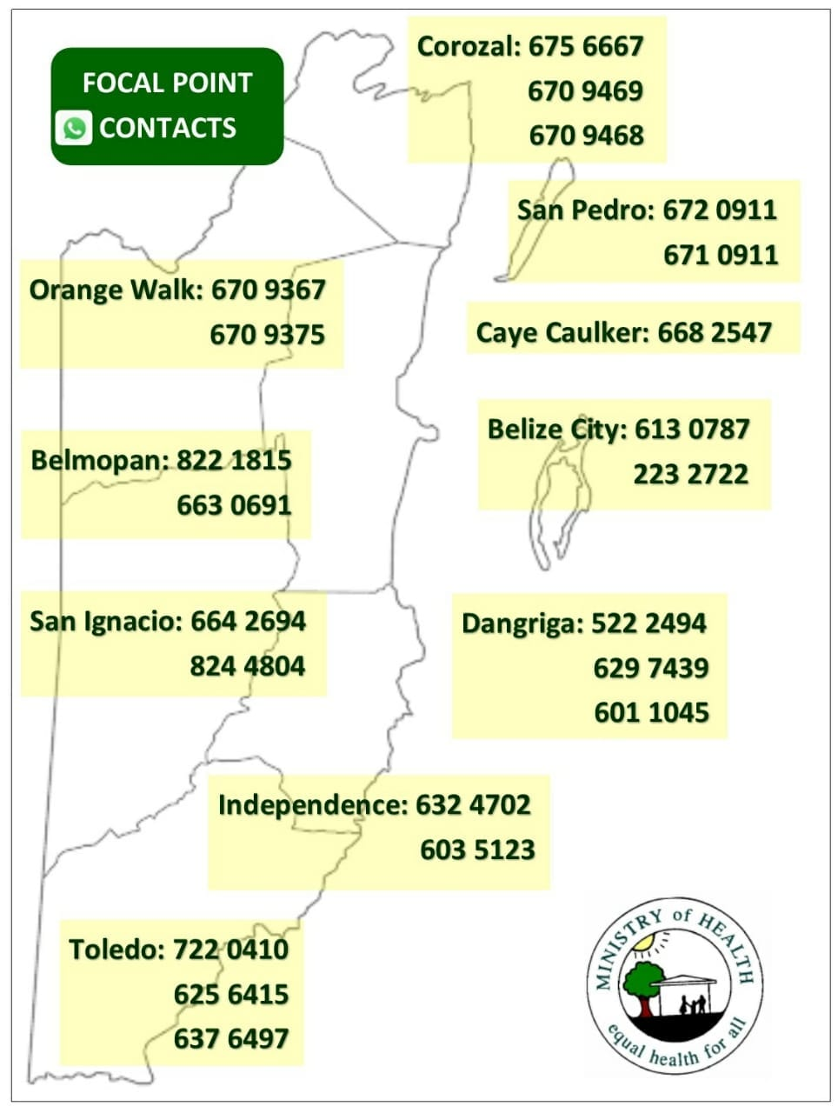

- For reference of reporting: Note below sample logs or attach image if you already have logs.
  - Logs attached:
    - Employee temperature log (insert log here)
    - COVID-19 symptomatic log template (insert log here)
    - Vendors and Suppliers log (insert log here)
    - Employee shift log template (insert log here)
    - Provide reservations and guest log template (insert log here)
    - Other

I agree to use the below sample logs (Check box if you agree and ensure to have logs printed for inspection)

  - Employee Temperature and monitoring logs
Date | Time | Employee Name | Recorded Temperature | Screener Name | Comments

  - Covid-19 symptomatic log
Date | Guest or Employee Name | Email address | Emergency Contact info | Gender | Age | Symptoms | Time observed | Action Taken

  - Vendor and Suppliers log
Date | Time | Supplier Name | Employee who attended supplier | Recorded Temperature | Screener name | Comments

  - Employee shift logs
Date | Time arrived | Time out | Time out | Total Hours Worked | Signature of employee

  - Reservations guest logs
Date | Time | Guest Name | Recorded Temperature | Accommodation name | Comments

If your logs are different, please insert pictures below

3) Ensure Social Distancing Protocols
- Attached are pictures of social distancing in all of the below areas. For reference, ensure to include x markers with tape/ stickers to show standing areas and signage for guests where applicable. Show sneeze guards where required.
  - Place in strategic locations such as:
    - Waiting area
    - Table and Seating set up
    - Bar seating set up
    - Others that requires 6 ft distancing
Insert images below of your facility meeting the social distancing requirements
Area | Picture
For example- Tables seating area | 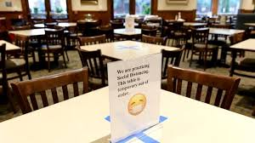
Waiting area
Bar seating

4) Implement Enhanced cleaning and Sanitization
- Staff
  - All employees will be provided a hand sanitizer for daily use
  - All staff will wear masks
  - Face shields will be optional depending of employee duties or health risk)
  - Gloves will be used depending on employee duties when handling equipment

Below are logs for tracking of enhanced cleaning and sanitation. For reference use below samples or attach image if you already have logs.

I agree to use the below sample logs (Check box if you agree and ensure to have logs printed for inspection)

  - FOH Cleaning Log
Area | Employee/ Company | Date | Time | Signature
Reception | John Doe | Dec 10, 2020 | 5:15pm

  - Cleaning/ disinfection common areas
Area | Employee/ Company | Date | Time | Signature
Staff lounge | John Doe | Dec 10, 2020 | 5:15pm

  - Deep Cleaning Log for BOH/ Kitchen

Area | Employee/ Company | Date | Time | Signature
Kitchen | John Doe | Dec 10, 2020 | 5:15pm

  - Bathroom Cleaning Log

Bathroom | Employee/ Company | Date | Time | Signature
Stall 1 Male | John Doe | Dec 10, 2020 | 5:15pm

  - Table Seating Log

Table # | Waiter | # of guests | Signature
10 | John Doe
If your logs are different, please insert pictures below:

- Provide inventory list of cleaning material and PPEs
ITEM | QUANTITY
Surgical Masks
Gloves(box of 50 pairs)
Bleach1 gallon | 5
Baceteria killing agents chemicals | 10
Sprayers | 5

- Attached are images of PPE and cleaning equipment
Area | Picture
Example of PPE purchased | 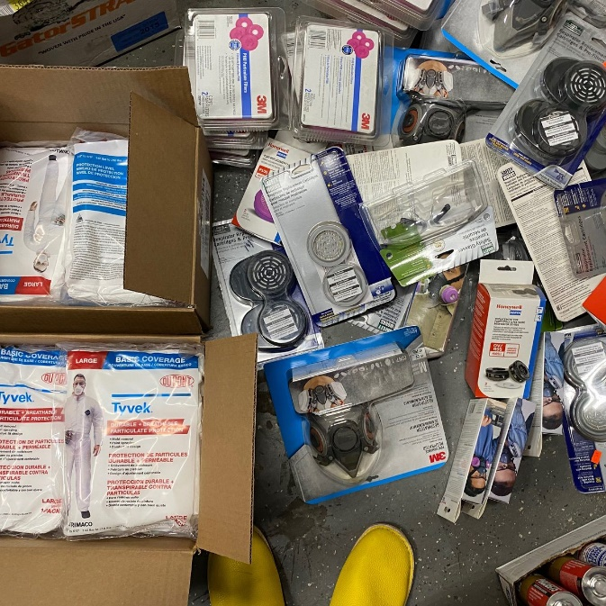

- Disposal of waste
  - All employees will wear protective gloves and face masks when handling trash. Trash bins will be lined with bags and tied off securely when full.
  - All bags with possible contamination will be sealed in red bag and disposed separately.

5)Develop a Response Plan
- Employee must follow the following steps to deal with symptomatic person
Kindly insert step by step response plan based on your operations. See samples below
    - Contact the Program Manager who will serve as the link between suspected case and the health authorities
    - If employee is symptomatic, they shouldn’t come into work and report it to the program manager and seek medical attention.
    - If employee reported to work and became symptomatic, the Program Manager should send employee home and proceed to seek medical advice.
    - Should someone become positive, the process of contact tracing by MOH will be used as a guide to send other staff into isolation, logs of symptomatic employees will be updated and disinfecting and sanitizing logs will be updated
  - Any Customer that arrives with symptoms will be denied entry to the restaurant and advised to seek medical attention.
6)Ensure Clear and Consistent Communication
- Signage
  - Below are images of signage around the waiting area, dining area and bathrooms. Reference annex signs of social distancing, proper hand washing and symptoms for constant reminders to guest and staff. You can print and laminate these to stick in strategic locations.

Insert images of signage around the property.
Area | Picture
For example- Entrance | 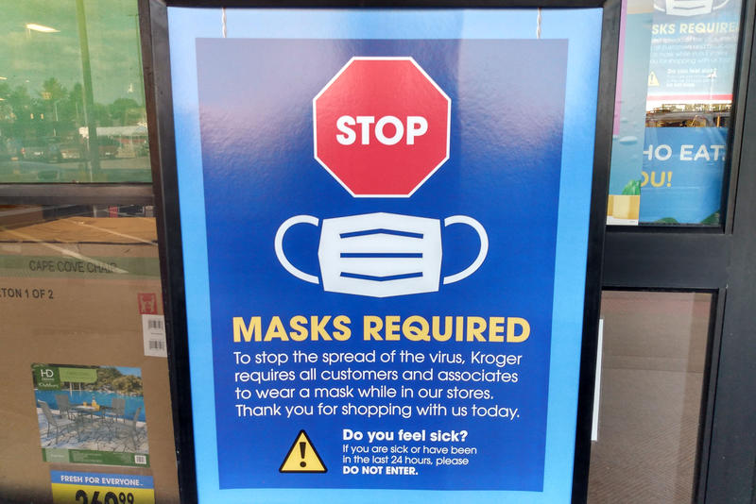

- Employee Communication below has been sent to all staff on how to maintain safety measures at home.
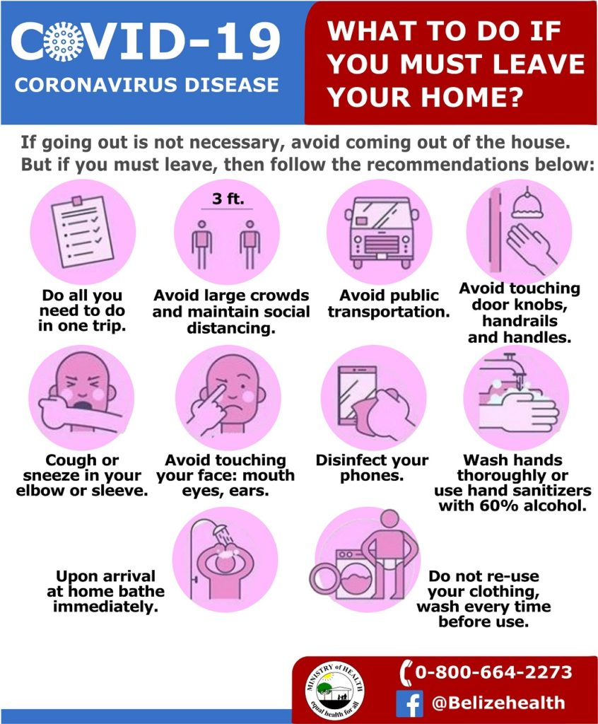

7)Install Sanitizing Stations
Attached are images of sanitizing stations installed equipment with soap dispensers, sanitizer gel, single use towels, etc
Insert images below of your sanitizing stations throughout the site

Area | Picture
For example- Sanitizing stations | 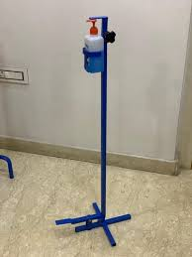

8)Deploy New Technology (If applicable)
- Attached are images of payment process (credit card, pre check-in credit card, website, online transfer, digital ticketing, QR code, etc.

Insert images below of any new technology implemented to make contactless operations

Area | Picture or URL link
Example- change in menus | 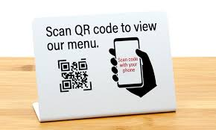
Example- online reservations | 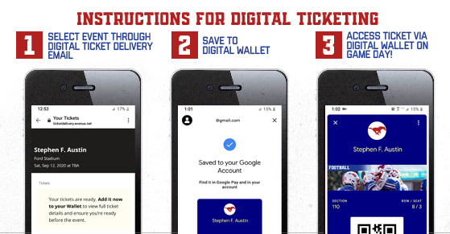

9)Implement a Training Plan
- All employees will be trained on the new protocols implemented. Training offered will be logged using the template below (Insert log if you have your own template). Images will also be kept for records. (Insert images if available)
Sample Training Log

Training | Date attended staff | Names of staff | Signature

Attach images of training sessions

Annex- Sample Signage
