Standard Operating Procedures for

[Accommodation Name]

9 Point Checklist for Gold Standard Recognition Program

The below is a sample template to guide Accommodations in developing the Standard Operating Procedures (SOP) to obtain a Gold Standard Recognition.

Name of Accommodation______________________________
Accommodation license #______________________________________

1) Appoint a Tourism Gold Standard Manager
- Contact information of the appointed Gold Standard Manager
  - Name________________________________________
  - Phone________________________________________
  - Email_________________________________________
- Name of Alternate Gold Standard Manager
  - Name__________________________________________
  - Phone__________________________________________
  - Email___________________________________________

- Duties and responsibilities of the Gold Standard Manager
- Develop and implement the health and safety plan for the property
- Ensure that all employees have done the 5 training sessions
- Ensure that all employees know the procedures on how to handle a symptomatic case.
- Ensure that all logs are being followed at the property
- Conduct spot checks to ensure all protocols are being followed
- Ensure all employees have PPE and disinfecting/ sanitizing equipment
- Liaise with Ministry of Health on any symptomatic employee or guest, update Health app and provide any logs necessary for contact tracing
- Ensure that Accommodation’s SOPs are reviewed and modified as necessary
- Implement corrective actions when staff and guests are non-compliant with protocols
- List Others:
- ____________________________________________________________________________________________________________________________________________________________________________________________________________________________________________________________________________________________________________________________________________________________________________________________________________________________________________________________________________________________

- Dates of training done by Gold Standard Manager and Alternate
    - For reference click here for link to training videos
Training | Date and signature attended by Gold Standard Manager | Date and signature attended by Gold Standard Manager Alternate
Introduction to BTB Tourism Gold Standard for accommodations | Insert signature and dates attended in this column | Insert signature and dates attended in this column
Tourism Gold Standard Program Manager training
Housekeeping, front of house and back of house for accommodations
Sanitizing and cleaning guidelines for accommodations
How to handle suspected case of COVID-19 among staff and guests
Other

2) Implement Monitoring and Reporting
Monitoring
  - Employee checks:
    - If employee is sick, he should not come to work and report to Program Manager.
    - Every employee’s temperature will be checked every day before entry on to the property and logged at the staff entrance.
    - Every employee will be asked the following questions:
      - Have you been in close contact with a suspected or confirmed case of COVID 19?
      - Are your experiencing a cough, shortness of breath or sore throat
      - Have you had a fever in the last 48 hours?
      - Have you had a loss of smell or taste?
      - Have you had any vomiting or diarrhea in the last 24 hours?
      - Does anyone in your immediate household present these symptoms?
    - If multiple answers are yes, the employee will be isolated and the response plan will be activated.

  - Guests
    - All guest’s temperatures will be taken before check in and logged.
    - Any symptomatic guest will be isolated and the response plan will be activated.
  - Vendors and supplier’s temperature will be taken and logged prior to entrance into office. No outside visitors will be allowed without being checked and logged entry.
  - Security personnel and all staff will report any observations of guests and staff that appear to be symptomatic or non-compliant with protocols.
  - All will be observed for the following symptoms and reported:
    - Less serious symptoms
      - Fever
      - Dry cough
      - Headache
      - Conjunctivitis
      - Tiredness (prior to tour activities)
      - Loss of taste and smell
      - A rash on skin or discoloration of fingers or toes.
      - Aches and pains
      - Sore throat
      - Diarrhea
    - Serious symptoms
      - Difficulty breathing or shortness of breath
      - Chest pain or pressure
      - Loss of taste and smell
    - Any symptom will be communicated via the Ministry of Health App, the hotline 0-800-MOH- CARE
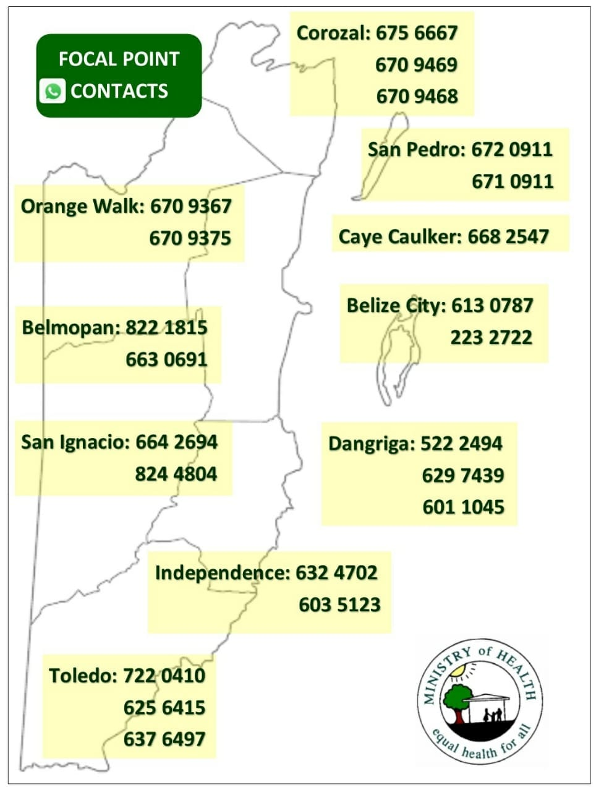

- For reference of reporting: Click here to download sample logs or insert image if you already have logs.
  - Templates of Log sheets used:
    - Employee temperature log (insert log here)
    - Guest Temperature log (insert log here)
    - Vendors and Suppliers log (insert log here)
    - Employee shift log (insert log here)
    - Restaurant seating log(insert log here)
    - Transport log (insert log here)
    - Other
3) Ensure Social Distancing Protocols
- Insert are pictures of social distancing in all of the below areas. For reference ensure to include x markers with tape/ stickers to show standing areas and signage for guests where applicable.
  - Place in strategic locations such as:
    - Hotel Lobby/ Reception area in office
    - Check in counters/ reception desk
    - Seating or waiting areas
    - Restaurant areas
    - Public areas (swimming pool, beach, bar, spa, etc)
    - Fitness rooms/ Gym
    - Seating Chart for restaurant and other areas
    - Others that require 6 ft distancing
Insert the images in the relevant areas

4) Implement Enhanced cleaning and Sanitization
Staff
  - All employees will be provided a hand sanitizer for daily use
  - All staff will wear masks and/or face shields
  - All staff will wear gloves when handling equipment
- Below are logs for tracking of enhanced cleaning and sanitation. For reference use below samples or insert image if you already have logs.

Sample Logs
  - Cleaning and disinfecting time log fleet
Vehicle | Employee | Date | Time | Signature
Ex- Vehicle C-1967 | John Doe | Dec 10, 2020 | 5:15pm

  - Cleaning disinfection Hotel Lobby/ Reception area
Office | Employee/ Company | Date | Time | Signature
Reception desk | John Doe | Dec 10, 2020 | 5:15pm
waiting area
Bathroom

  - Cleaning disinfection rooms
Rooms | Employee/ Company | Date | Time | Signature
Toucan Room | John Doe | Dec 10, 2020 | 5:15pm

  - Cleaning disinfection Public areas
Public areas | Employee/ Company | Date | Time | Signature
Pool | John Doe | Dec 10, 2020 | 5:15pm
Gym
Spa
Pool Bathroom
Doors knobs
Staircases/ elevators

  - Cleaning disinfection Restaurant and bar
Restaurant and Bar | Employee/ Company | Date | Time | Signature
Table 1 | John Doe | Dec 10, 2020 | 5:15pm
Table 2
Bar

- Below is a checklist of high touch point of different areas and how to clean each respectively. For reference below are some suggestions or insert images of checklist for each area to be cleaned. Review pages 30 to 42 of Tourism Health and Safety Enhanced Hotel and Restaurant Guidelines to determine best recommended cleaning equipment depending on area.

Sample high touch point checklists

  - Hotel Lobby or reception area-
AREA | HOW TO CLEAN | EQUIPMENT NEEDED | Frequency | CHECK IF COMPLETED
Example: Counter check in areas | Wipe with Designated rag with bleach and water, make sure bleach mixture is no more than 3 days old……. | Gloves, rag, spray bottle with mixture of 2 parts water 1 part bleach | After every guest
Computer, credit card machines, keyboard, mouse, calculator, etc | Insert “How to clean” description here for the respective area as per the example above. | Insert “Equipment needed” here for the respective area as per the example above. | Insert “frequency” description for the respective area as per the example above.
Door knobs
Phone system
Credit Card system
Waiting area chairs
Check in counters
Other

  - Transportation vehicle
AREA | HOW TO CLEAN | EQUIPMENT NEEDED | Frequency | CHECK IF COMPLETED
Door handles | Designated rag with bleach and water, make sure bleach mixture is no more than 3 days old, | Gloves, rag, spray bottle with mixture of 2 parts water 1 part bleach | After every guest use
Seats | Sanitizing interior with warm water and soap, scrub then vacuum upholstery. If seats have plastic, then a bleach solution mixture can be sprayed and wiped down. | Gloves, soap, water, bucket, scrub, rag, vacuum; or bleach, rag, gloves | After every guest use
Windows
Window buttons
Air condition vent and controls
Other

  - Transportation boats
AREA | HOW TO CLEAN | EQUIPMENT NEEDED | Frequency | CHECK IF COMPLETED
Seating area | Hose down with soap and water, add bleach mixture for added sanitization for exterior. | Gloves, rag, spray bottle with mixture of 2 parts water 1 part bleach. | After every guest use
Captain’s Chair
Steering wheel and driver controls
Handle rails
Cooler
Cushions boat seat
Other

  - Public Restroom
AREA | HOW TO CLEAN | EQUIPMENT NEEDED | Frequency | CHECK IF COMPLETED
Door handle | Hose down with soap and water, add bleach mixture for added sanitization | Gloves, rag, spray bottle with mixture of 2 parts water 1 part bleach | Hourly
Sink and faucet
Floor
Soap dispenser
Toilet paper dispenser
Toilet
Light switches

  - Guest rooms
AREA | HOW TO CLEAN | EQUIPMENT NEEDED | Frequency | CHECK IF COMPLETED
Beds | Linens to be removed and bagged.
Bathroom
Mini fridge
Coffee
Electrical switches

  - Restaurant and Bar
AREA | HOW TO CLEAN | EQUIPMENT NEEDED | Frequency | CHECK IF COMPLETED
Kitchen | Wash down with soap and water, add bleach mixture for added sanitization | Gloves, rag, spray bottle with mixture of 2 parts water 1 part bleach | Hourly
Tables and seating area
Bar area
Table cloths
Condiments
Menus

  - Public areas
AREA | HOW TO CLEAN | EQUIPMENT NEEDED | Frequency | CHECK IF COMPLETED
Hot tubs | Hose down with soap and water, add bleach mixture for added sanitization | Gloves, rag, spray bottle with mixture of 2 parts water 1 part bleach | Hourly
Bathroom
Pool chairs
Beach chairs

  - Equipment
AREA | HOW TO CLEAN | EQUIPMENT NEEDED | Frequency | CHECK IF COMPLETED
Kayaks | Hose down with soap and water, add bleach mixture for added sanitization | Gloves, rag, spray bottle with mixture of 2 parts water 1 part bleach | Hourly
Paddle Boards

  - Laundry
AREA | HOW TO CLEAN | EQUIPMENT NEEDED | Frequency | CHECK IF COMPLETED
Guests Bagged laundry | Linens to be removed and bagged.
Dirty linens from housekeeping
Towels

  - Gym/ Fitness Center
AREA | HOW TO CLEAN | EQUIPMENT NEEDED | Frequency | CHECK IF COMPLETED
Weight machines | Wipe down with bleach mixture or 60% alcohol | Gloves, rag, spray bottle with mixture of 2 parts water 1 part bleach | Hourly
Showers

  - Spa
AREA | HOW TO CLEAN | EQUIPMENT NEEDED | Frequency | CHECK IF COMPLETED
Spa beds
Equipment

- Disposal of waste
  - All employees will wear protective gloves and face masks when handling trash. Trash bins will be lined with bags and tied off securely when full.
  - All bags with possible contamination will be sealed in red bag and disposed separately.
5)Develop a Response Plan
- All staff must follow the following steps to deal with symptomatic guest and staff
Kindly insert step by step response plan based on your operations. See samples below
  - Clock in staff
    - isolate staff at designated location at site or isolate at____________________________________________
    - contact the Program manager (Program Manager will contact MOH
    - update logs of COVID-19 case
    - log cleaning

  - Check in at hotel lobby/ reception desk
    - isolate guest at designated location at site or isolate at____________________________________________
    - contact the Program manager (Program Manager will contact MOH
    - update logs of COVID-19 case
    - disinfect and sanitize Lobby/ reception desk
    - log cleaning
  - During stay
    - isolate guest at designated location at site or isolate at____________________________________________
    - contact the Program manager (Program Manager will contact MOH
    - if symptoms are severe organize with MOH to be taken to medical facility in an approved transport vehicle
    - update logs of COVID-19 case
    - disinfect and sanitize vehicles and rooms
    - log cleaning of all vehicles and rooms

- Closest medical facility identified (Insert name and contact information)
    - _________________________________________
    - _________________________________________

- Additional notifications- Gold Manager(s) will assist guests with contacting their local diplomatic mission. This is often done to register their location and situation in a country if necessary. Should the guest(s) choose to contact the embassy directly they are free to use the local line. Should guest(s) request that the mission be contacted on their behalf then Management will request an electronic copy of their ID for verification purposes.

- Cleaning and disinfecting procedures after symptomatic guest depart:
(Insert step by step procedure for all areas being cleaned including but not limited to the use of PPE, cleaning solutions, cleaning equipment, isolation time, etc. If a professional cleaning company is being contracted, insert name and contact information.)

- See below inventory list of cleaning material, equipment and PPEs
ITEM | QUANTITY
Insert list of cleaning material, equipment and PPE in stock. | Insert corresponding quantity for each item listed.

- See below images of PPE and cleaning equipment
Insert images to correspond with your inventory

6) Ensure Clear and Consistent Communication
- Hotel policies
- The hotel has implemented all the safest measures in all efforts to reduce risk for guests and employees.
- Masks required at all times, with only exceptions:
    - Once guest is seated in a restaurant to eat
    - Beach/ pool or public space on property once sufficient distance is maintained from other guests.
- Booking will be flexible to accommodate payment reimbursements should a guest become symptomatic prior to check-in.

- Guest Communication Plan
- Draft email that will be sent to guests to explain protocols, reimbursements and expectations on booking
Sample email or insert the email used by your accommodation
Dear Guest,
Thank you for your interest in staying at ______________. We are happy to inform you that our accommodation is a Tourism Gold Standard Recognized Accommodation; which means we have implemented all measures to mitigate any risks for our guests and employees. Our accommodation has also been designated within the safe corridor (as seen in image below which means every contact you have during your stay has been trained to ensure your safety.
What to expect during your stay?
    - Arrange pick up at airport with us at a cost of $xxx or book with local airlines (Maya Island Air or Tropic Island Air).
    - Expect to have your temperature tested upon pick up.
    - Masks required at all times, with only exceptions:
        - On a high intensity tour where the guide is 6 feet apart. For example- hiking, rappelling.
        - Snorkeling
        - Once guest is seated in a restaurant to eat
        - Beach once sufficient distance is maintained from other guests.
    - Enjoy dining at our _________________ restaurant or delivery can be arranged from our local restaurants.
    - Booking will be flexible to accommodate payment reimbursements should you become symptomatic prior to arrival (submit Covid-19 positive test).
Thank you for your support and continued patience as we continue to work towards safely providing our services for you to enjoy our beautiful Belize.
Sincerely,
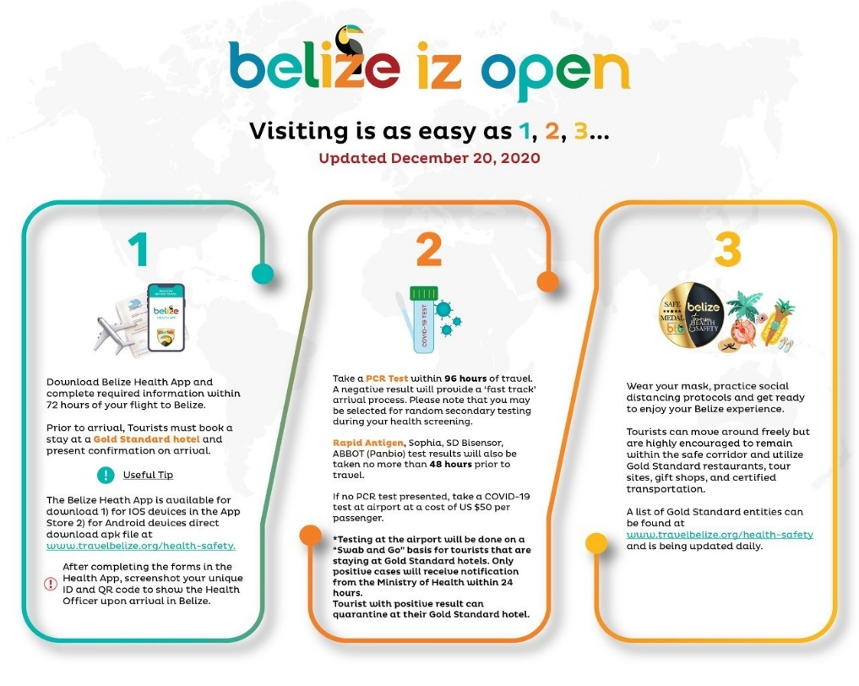
- Sample disclaimer- penalties of non-compliance with masks, cost of quarantine if positive, or any other liability clauses
Insert image
- Employee Communication below has been sent to all staff.
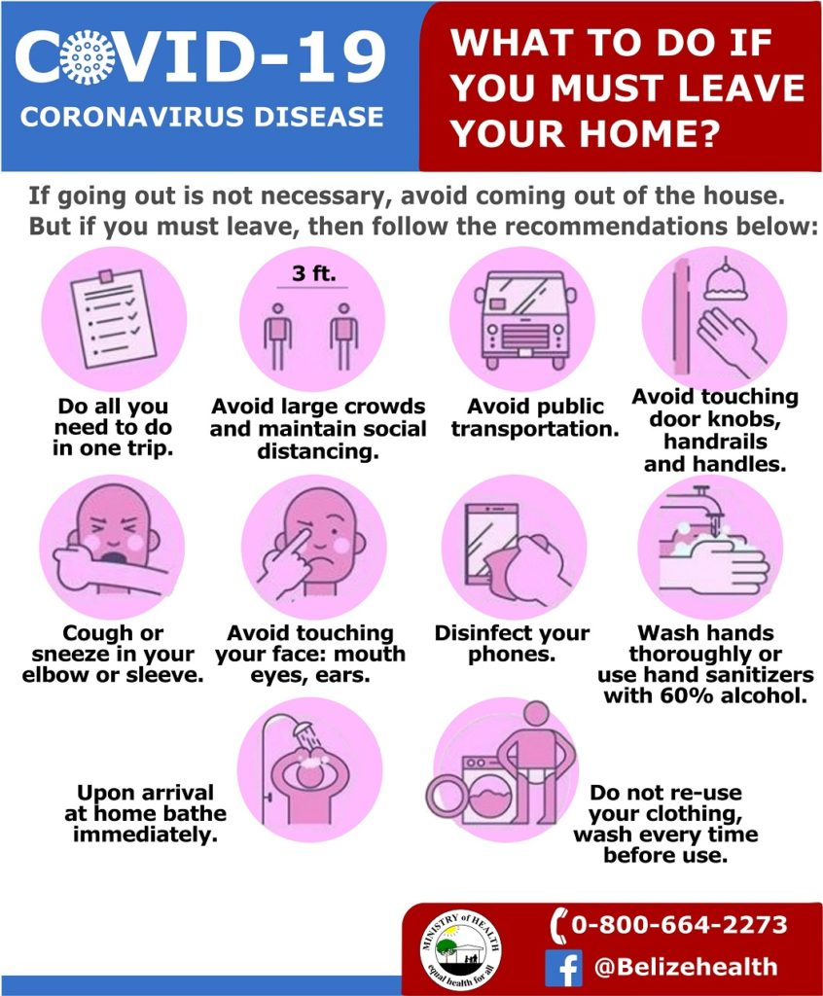

- Publicized Standard Operating Procedure will be shared via __________________________ (Insert website link, social media link or email address where applicable)

- Platforms used to reinforce the message to guests: E.g. Email, Facebook, Online booking etc.
Insert image

- Signage
Below are images of signage around the property. (Signs of social distancing, proper hand washing and symptoms for constant reminders to guest and staff)

Insert images installed in all areas around the property (front desk, Lobby), rooms, other public spaces, etc.

- See below information shared to guestless that is contactless or can be sanitized.
(Insert image of laminated, digital or QR code of menu, welcome booklet, and any other information available that is contactless or can be sanitized.)

7) Install Sanitizing Stations
- See below images around the property of sanitizing stations, installed equipment with soap dispensers, sanitizer gel, single use towels, etc.
Insert images and list location of sanitizing station

8) Deploy New Technology
- See below description and images of payment process (credit card, pre check-in credit card, website, online transfer, etc.)
Insert description and screenshots or images.

- See below description and images of pre-check in process such as digital ticketing, email confirmations, etc.
Insert description and images.

- See below images of any other use of technology to reduce physical contact. (App, QR codes of flyers, menus, etc.) (If applicable)
Insert images here

9) Implement a Training Plan
- All employees will be trained on the new protocols implemented. Training offered will be logged using the template below (Insert log if you have your own template). Images will also be kept for records. (Insert images if available)
Sample Training Log
Training | Date attended | Staff Names | Signature

Annex
