TOURISM GOLD STANDARD CERTIFICATION
APPLICATION CHECKLIST
For Gift Shops
Declaration:
I hereby certify that all information provided in this application and plan is true, accurate and complete to the best of my knowledge. I have not withheld any information and understand any falsification is illegal and will disqualify this application.
Print Name of Gold Standard Manager_________________________________
Signature of Gold Standard Manager___________________________________
Name/ Address of the Gift Shop_____________________________________
Date: ____________________________________________________________
Applicants must also submit copies of Company Registry, Trade License or Incorporation Certificate along with their submission. Below checklist must be submitted in the plan to: entitygoldstandardapplication@belizetourismboard.org
Program Manager
 |  | Yes | NO | COMMENTS
1. | Name of Program Manager and alternate has been submitted
2. | List of duties and job responsibilities of program manager have been submitted
3. | Program Manager and Alternate has complete 3 gift shop webinars
TOTAL |  | 0/3

Implement Monitoring & Reporting
Did the Gift Shop provide the following at the time of submission?
 |  | YES | NO | COMMENTS
1. | Employee temperature log
2. | Supplier/Vendor temperature Log
3. | Employee Shift Log
4. | Covid-19 Symptomatic Log
5. | Guest Temperature Log
6. | Identified Closest Medical Facility
TOTAL |  | 0/6

Ensure Social Distancing Protocols
Did the Gift Shop provide the following at the time of application?
 |  | YES | NO | COMMENTS
1. | Images of Social distancing signage at entrance area
2. | Images of Social distancing signage inside the Gift shop
3. | Images of Social distancing signage at the cashier area
4. | Images of social distancing any other area
5. | Images of social distancing layout inside the gift shop
TOTAL |  | 0/5

Implement Enhanced Cleaning & Sanitization Procedures
Did the Gift Shop provide the following at the time of application?

 |  | YES | NO | COMMENTS
1. | Cleaning and disinfecting time-log (includes time, employee conducting cleaning, cleaning of following areas: FOH, Common Areas, BOH/ Kitchen, Bathroom)
2. | Provide list of PPE equipment in inventory (Gloves, masks, face shield*, thermometer, bleach, bacteria cleaning agent, antibacterial solution or alcohol)
3. | Provide images of PPE purchased and are on the premises.
4. | Provided images of cleaning equipment (soap, sprayer, buckets, designated clothes)
TOTAL |  | 0 /4

Develop a Response Plan
Did the Gift Shop provide the following at the time of application?
 |  | YES | NO | COMMENTS
1. | Provide list of steps to deal with symptomatic employee
TOTAL | 0 /1

Ensure Clear & Consistent Communication
Did the Gift Shop provide the following at the time of application?
 |  | YES | NO | COMMENTS
1. | Provide images of signage installed throughout the shop with COVID-19 best practices, Health and Safety protocol signage (hand washing, mask wearing, etc)
TOTAL |  | 0/1

Install Sanitizing Stations
Did the Gift Shop provide the following at the time of application?
 |  | YES | NO | COMMENTS
1. | List and pictures of locations where hand sanitizing or hand washing stations have been set up
TOTAL |  | 0 /1

Deploy New Technology
Did the Gift Shop provide the following at the time of application?
 |  | YES | NO | COMMENTS
1. | Images of any new technology implemented to reduce contact (Ex QR codes for information, digital tickets, etc)
2. | Images of contactless payment methods, credit card or sanitizing of cash stations, etc
TOTAL |  | 0 /2
-

Implement a Training Plan
Did the Gift Shop provide the following at the time of application?
 |  | YES | NO | COMMENTS
1. | Training schedule/ logs
2. | Images of training
TOTAL |  | 0 /2

Health and Safety Protocols for

[Gift Shops]

Checklist for Health and Safety Protocols

The below is a sample template to guide Gift Shops in developing the Health and Safety Protocols to open in the safe corridor. Please fill everything in red and attach images where necessary.
Updated May 31, 2021

Name of Gift Shop______________________________________________
Address of Gift Shop_____________________________________________
Destination of Gift Shop_____________________________________________

1) Appoint a Tourism Gold Standard Manager
- Contact information of the appointed Manager
  - Name________________________________________
  - Phone________________________________________
  - Email_________________________________________
- Duties and responsibilities of the Manager/ Supervisor
- Ensure that employees have done health and safety training sessions
- Ensure that employees are aware of the procedures on how to handle a symptomatic case.
- Ensure that all logs are being followed on entry
- Conduct spot checks to ensure all protocols are being followed by employees
- Ensure all employees have PPE and disinfecting/ sanitizing equipment
- Liaise with Ministry of Health on any symptomatic employees, and provide any logs necessary for contact tracing
- Ensure that gift shop Protocols are reviewed and modified as necessary
- Implement corrective actions when staff and guests are non-compliant with protocols
- List Other Duties & responsibilities:
- ________________________________________________________________________________________________________________________________________
- Dates of training done by Gold Standard Manager and Alternate
*Training videos are posted on www.belizetourismboard.org

Training | Date attended by Gold Standard Manager | Name | Signature | Date attended by Alternate Manager | Name | Signature
Introduction to the Tourism Gold Standard Program
Enhanced Safety Protocols for Gift Shops
Cleaning and Sanitization guidelines for Gift Shops
Other

2) Implement Monitoring and Reporting
- Monitoring
  - Employee checks:
    - If employee is sick, he should not come to work and report to Manager.
    - Every employee’s temperature will be checked every day before a shift and logged at the staff entrance.
    - Every employee will be asked the following questions:
      - Have you been in close contact with a suspected or confirmed case of COVID 19?
      - Are your experiencing a cough, shortness of breath or sore throat
      - Have you had a fever in the last 48 hours?
      - Have you had a loss of smell or taste?
      - Have you had any vomiting or diarrhea in the last 24 hours?
      - Does anyone in your immediate household present these symptoms?
    - If multiple answers are yes, the employee will be asked to home and seek medical attention.

  - Guests
    - Any guest that is observed to be symptomatic will be denied entry.
  - Vendors and supplier’s temperature will be taken and logged prior to entrance into office. No outside visitors will be allowed without being checked and logged entry.
  - Security personnel and all staff will report any observations of guests and staff that appear to be symptomatic or non-compliant with protocols.
  - All will be observed for the following symptoms and reported:
    - Less serious symptoms
      - Fever
      - Dry cough
      - Headache
      - Conjunctivitis
      - Tiredness (prior to tour activities)
      - Loss of taste and smell
      - A rash on skin or discoloration of fingers or toes.
      - Aches and pains
      - Sore throat
      - Diarrhea
    - Serious symptoms
      - Difficulty breathing or shortness of breath
      - Chest pain or pressure
      - Loss of taste and smell
    - Any symptom will be communicated via the Ministry of Health App, the hotline 0-800-MOH- CARE
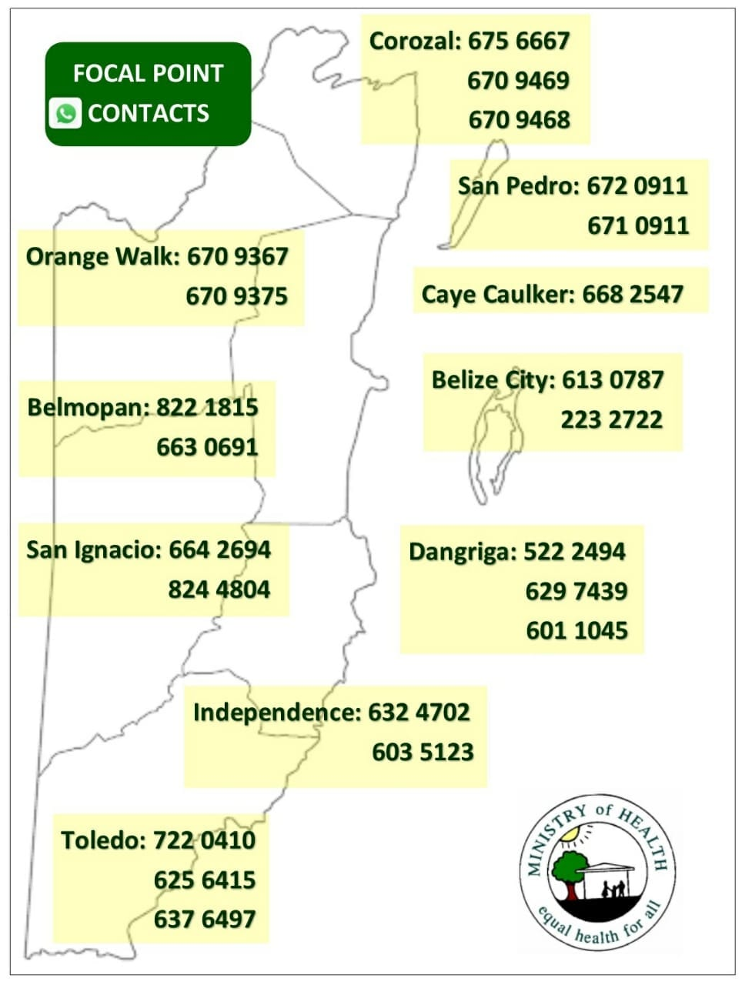
    - Closest Medical facility
      - Location: ______________________________________________
      - Phone Number: ________________________________________

- For reference of reporting: Note below sample logs or attach image if you already have logs.
  - Logs attached:
    - Employee temperature log (insert log here)
    - COVID-19 symptomatic log template (insert log here)
    - Vendors and Suppliers log (insert log here)
    - Employee shift log template (insert log here)
    - Provide reservations and guest log template. (insert log here)
    - Other

I agree to use the below sample logs (Check box if you agree and ensure to have logs printed for inspection)

  - Employee Temperature and monitoring logs
Date | Time | Employee Name | Recorded Temperature | Screener Name | Comments

  - Covid-19 symptomatic log
Date | Guest or Employee Name | Email address | Emergency Contact info | Gender | Age | Symptoms | Time observed | Action Taken

  - Vendor and Suppliers log
Date | Time | Supplier Name | Employee who attended supplier | Recorded Temperature | Screener name | Comments

  - Employee shift logs
Date | Time arrived | Time out from tour | Time out | Total Hours Worked | Signature of employee

If your logs are different, please insert pictures below:

3) Ensure Social Distancing Protocols
- Attached are pictures of social distancing in all of the below areas. For reference ensure to include x markers with tape/ stickers to show standing areas and signage for guests where applicable. Also insert pictures of sneeze guards where applicable.

  - Place in strategic locations such as:
    - Images of the Entrance of Gift Shop
    - Images of Layout of Entrance
    - Images inside the Gift Shop
    - Images by the Cashier Area
    - Images at any other area
- Insert images below of your facility meeting the social distancing requirements

Area | Picture
For example- Entrance Area (showing signage and floor marking) | 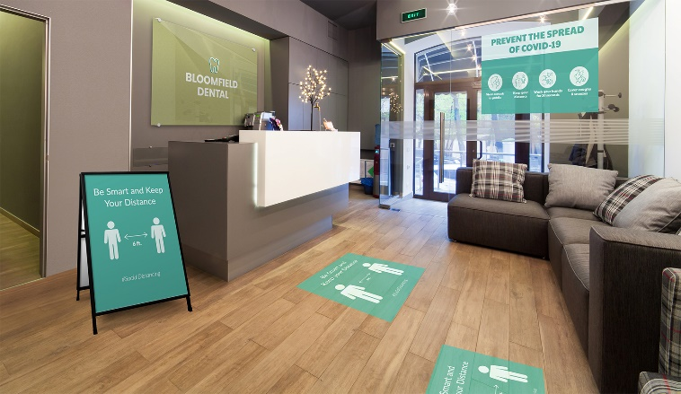
Inside the Gift Shop
Cashier Area of Gift Shop

Any Other Area

4) Implement Enhanced cleaning and Sanitization
- Staff
  - All employees will be provided a hand sanitizer for daily use
  - All staff will wear masks and/or face shields
  - Face shields will be optional depending of employee duties or health risk
  - Gloves will be used depending on employee duties when handling equipment

- Below are logs for tracking of enhanced cleaning and sanitation. For reference use below samples or attach image if you already have logs.

I agree to use the below sample logs (Check box if you agree and ensure to have logs printed for inspection)

  - Cleaning/ Disinfection Gift Shop Items
Equipment | Employee/ Company | Date | Time | Signature
Displays | John Doe | Dec 10, 2020 | 5:15pm

  - Cleaning/ Disinfection Cashier
Office | Employee/ Company | Date | Time | Signature
Reception desk | John Doe | Dec 10, 2020 | 5:15pm
Credit card machine
Glass counters

High Touch Point Areas checklist-

AREA | High Touch Point areas | CHECK IF COMPLETED
Office | Desk  Computer  Keyboard  Credit Card machine  Phone
Equipment | All items displayed

If your logs are different, please insert pictures below:

- Provide inventory list of cleaning material and PPEs
ITEM | QUANTITY
Surgical Masks
Gloves(box of 50 pairs)
Bleach1 gallon | 5
Baceteria killing agents chemicals | 10
Sprayers | 5
Contact-less thermometer | 1

- Attached are images of PPE and cleaning equipment
Insert images of all PPE purchased and is in inventory at the site
Example of PPE: 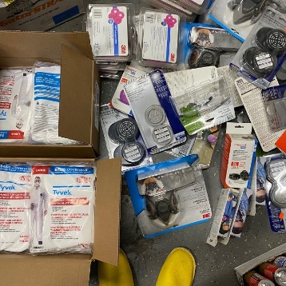

- Disposal of waste
  - All employees will wear protective gloves and face masks when handling trash. Trash bins will be lined with bags and tied off securely when full.
  - All bags with possible contamination will be sealed in red bag and disposed separately.

4) Develop a Response Plan
All staff must follow the following steps to deal with symptomatic person
Kindly insert step by step response plan based on your operations. See samples below

    - Anyone with symptoms will be denied entry into the gift shop.
    - Employees who are symptomatic should not report to work and notify Program Manager.
    - Should staff become ill at the gift shop; they will be sent home for medical attention.
    - Wait on report from MOH on how to proceed with employee.
    - update logs of COVID-19 case
    - disinfect and sanitize high touch point areas where case may have been in contact
    - log cleaning

5)Ensure Clear and Consistent Communication
- Signage
Below are images of signage around the entrance area, waiting area, cashier area, common area and bathrooms. Reference annex signs of social distancing, proper hand washing and symptoms for constant reminders to guest and staff. You can print and laminate these to stick in strategic locations.

Insert images of signage around the gift shop
Area | Picture
For example- Picture of Signs at Entrance

Signs at Cashier Area
Signs Inside the Gift Shop

7)Install Sanitizing Stations
- Attached are images of sanitizing stations installed equipment with soap dispensers, sanitizer gel, single use towels, etc
Insert images below of your sanitizing stations throughout the site

Area | Picture
Example- Sanitization Station at entrance area | 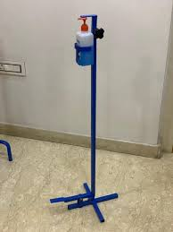
Sanitizing stations at cashier area
Sanitizing stations inside the gift shop or anywhere else

8) Deploy New Technology (If applicable)
- Attached are images of payment process (credit card, pre check-in credit card, website, online transfer, digital ticketing, QR code, etc.

Insert images below of any new technology implemented to make contactless operations

Area | Picture or URL link
Example of contactless payment (online payments, credit card, sanitizing cash station, etc.) | POS Machine
Any other technology to reduce physical contact | Online Payments Accepted

9) Implement a Training Plan
- All employees will be trained on the this plan with new protocols implemented. Training offered will be logged using the template below (Insert log if you have your own template). Images will also be kept for records. (Insert images if available)
Sample Training Log

Training | Date attended staff | Names of staff | Signature

Attach images of training sessions

Annex- Sample Signage
