Standard Operating Procedures for

[Accommodation Name]

Checklist for Gold Standard Recognition Program

Instructions: The below is a sample template to guide Accommodations in developing the Standard Operating Procedures (SOP) to obtain Gold Standard Recognition. Accommodations must complete sections in red and customize template to suit their accommodation. Once all sections are completed the plan must be submitted to qualityassurance@belizetourismboard.org

Name of Accommodation______________________________
Accommodation license #______________________________
Declaration:
I hereby certify that all information provided in this application and plan is true, accurate and complete to the best of my knowledge. I have not withheld any information and understand any falsification is illegal and will disqualify this application.
Print Name of Gold Standard Manager_________________________________

Signature of Gold Standard Manager___________________________________

Print Name of General Manager/Owner________________________________

Signature of General Manager/Owner__________________________________

Date: _________________

-------------------------------------------------------------------------------------------------------------------------

1) Appoint a Tourism Gold Standard Manager
- Contact information of the appointed Gold Standard Manager
  - Name________________________________________
  - Phone________________________________________
  - Email_________________________________________
- Name of Alternate Gold Standard Manager
  - Name__________________________________________
  - Phone__________________________________________
  - Email___________________________________________

- Duties and responsibilities of the Gold Standard Manager
- Develop and implement the health and safety plan for the property
- Ensure that all employees know the procedures on how to handle a symptomatic case.
- Ensure that all logs are being followed at the property
- Conduct spot checks to ensure all protocols are being followed
- Ensure all employees have PPE and disinfecting/ sanitizing equipment
- Liaise with Ministry of Health on any symptomatic employee or guest and provide any logs necessary for contact tracing
- Ensure that Accommodation’s SOPs are reviewed and modified as necessary
- Implement corrective actions when staff and guests are non-compliant with protocols
- List any other: (insert any additional duties/responsibilities assigned but not captured above)
- ____________________________________________________________________________________________________________________________________________________________________________________________________________________________________________________________________________________________________________________________________________________

2) Implement Monitoring and Reporting
Monitoring
  - Employees:
    - If employee is sick, he/she should not come to work and report to Program Manager.
    - Every employee will be asked the following questions:
      - Have you been in close contact with a suspected or confirmed case of COVID 19?
      - Are your experiencing a cough, shortness of breath or sore throat
      - Have you had a fever in the last 48 hours?
      - Have you had a loss of smell or taste?
      - Have you had any vomiting or diarrhea in the last 24 hours?
      - Does anyone in your immediate household present these symptoms?
    - If multiple answers are yes, the employee will be isolated and the response plan will be activated.

  - Guests
    - Any symptomatic guest will be isolated and the response plan will be activated.
  - Security personnel and all staff will report any observations of guests and staff that appear to be symptomatic or non-compliant with protocols.
  - All will be observed for the following symptoms and reported:
    - Less serious symptoms
      - Fever
      - Dry cough
      - Headache
      - Conjunctivitis
      - Tiredness (prior to tour activities)
      - Loss of taste and smell
      - A rash on skin or discoloration of fingers or toes.
      - Aches and pains
      - Sore throat
      - Diarrhea
    - Serious symptoms
      - Difficulty breathing or shortness of breath
      - Chest pain or pressure
      - Loss of taste and smell
    - Any observation of symptoms will be communicated via the Ministry of Health and Wellness (MOHW) hotline 0-800-664- 2273.
    - For contact tracing queries at the district level the following numbers below can be utilized:
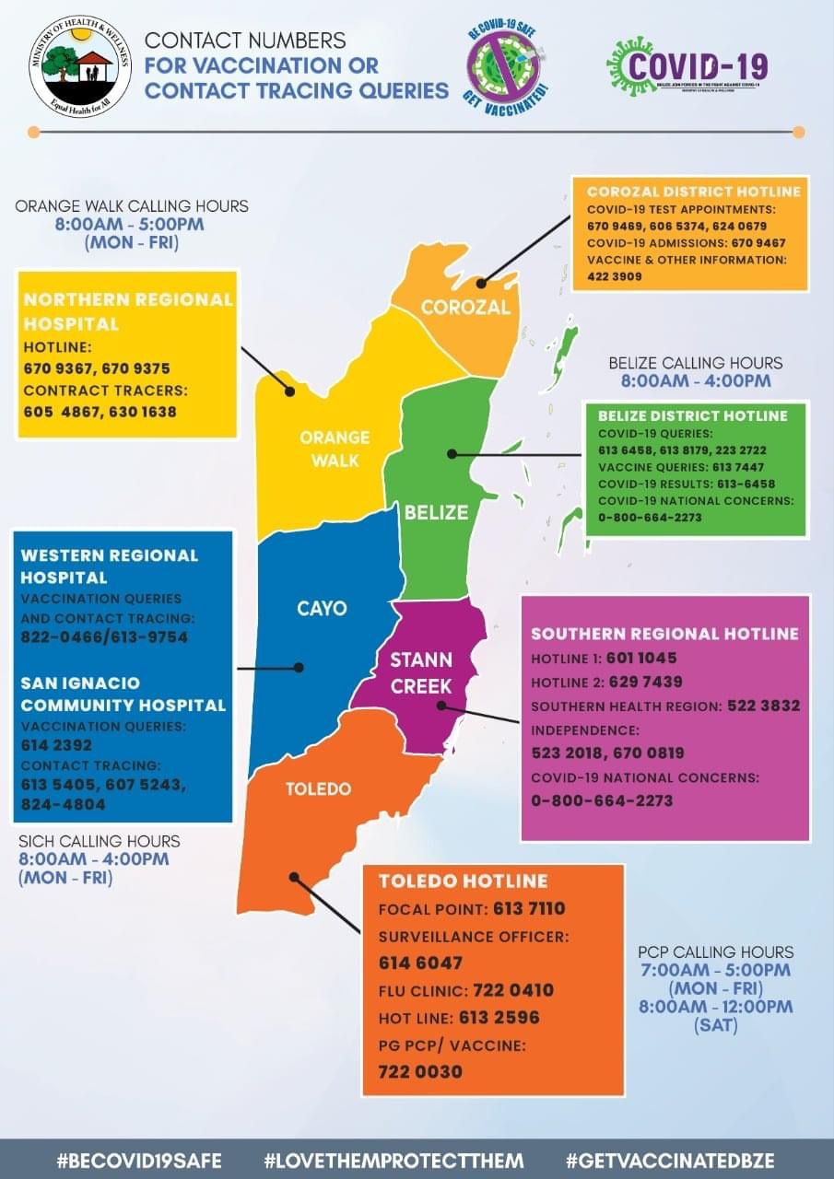

- For reference of reporting, the template below will be used to record any individual displaying symptoms, including elevated temperatures:
  - Templates of Log sheet used:
    - COVID-19 Symptomatic log
COVID-19 Symptomatic Log
Date | Guest or Employee name | Emergency contact information | Gender/Age | Symptoms observed | Place and time observed | Names of those in contact with symptomatic individual | Action taken

3) Implement Enhanced cleaning and Sanitization
Staff
  - Food and Beverage Staff shall wear facemasks when preparing and serving customers.
  - Housekeeping and kitchen staff will wear gloves when cleaning or preparing food and beverage.

- Cleaning and sanitization logs will be kept for all areas of the accommodation. Below are logs for tracking of enhanced cleaning and sanitization. For reference use below samples or insert image if you already have logs.

Sample Logs
  - Cleaning and sanitization time log fleet
Vehicle | Employee | Date | Time | Signature
Ex- Vehicle C-1967 | John Doe | Dec 10, 2020 | 5:15pm

  - Cleaning and sanitization for Rooms
Room Number | Employee/ Company | Date | Time | Signature
123 | John Doe | Dec 10, 2020 | 5:15pm

  - Cleaning and sanitization for restaurant
Area being cleaned | Employee/ Company | Date | Time | Signature
Kitchen & Dining | John Doe | Dec 10, 2020 | 5:15pm
Bar

  - Cleaning and sanitization for Public Areas
Area being cleaned | Employee/ Company | Date | Time | Signature
Reception area | John Doe | Dec 10, 2020 | 5:15pm

  - Water quality testing log for Pool
Daily Test |  |  |  |  |  | Weekly test |  | Chemicals Added |  | Maintenance & Notes
Date | Water Clarity | Disinfectant PPM | Combined Chlorine < 50% free | pH 7.2-8.0 | Flow GPM | Alkalinity Rec. Range 60-160 PPM | Cyanuric Acid if used < 90 | Quantity of Disinfectant Added | Other Chemicals Added | Backwash | Vacuum or Brush | Contaminant Episode

- Below is the general guidance for how to conduct enhanced cleaning and sanitization. For reference below are some suggestions or insert images of checklist for each area to be cleaned.
Enhanced Cleaning Checklist for areas being cleaned:
TERMINOLOGIES
Cleaning of visibly dirty surfaces followed by disinfection is a best practice measure for the prevention of Infectious Disease in the community setting.
Cleaning
•Cleaning is a pre-disinfection step to remove dirt.
• Removes dust and debris from a surface/s.
• Action by scrubbing, washing and rinsing.
Sanitize
• Reduces the bacteria identified on the product’s label
Disinfection
• Destroys or inactivates both the bacteria and viruses identified on the product’s label
• EPA-approved disinfectant

Guest Room Cleaning Checklist
Instructions:
- Evaluate room and prepare for cleaning. Remove all cutlery, dishes, glasses, debris and towels.
- Empty trash cans and replace trash can liners, if needed. Wipe the outside.
- Clean high-touch point surfaces and other hard surfaces and disinfect as needed.
- Remove old bed linens and inspect mattress for bed bugs. Make bed with fresh linens.
- Vacuum carpet or wipe and clean hard floor.
- Finish room by spraying air disinfectant on soft surfaces.
Note: Always ensure you wear correct Personal Protective Equipment

GUest room HIgh touch areas that require attention:
- Door and window handles &locks
- Tables, chairs & lamps
- Dresser drawer and curtain handles
- Light switches, thermostat & AC control
- Telephones
- Minibar & tableware
- Pens & Collaterals (e.g. welcome booklet)
- TV & Remote Control
- Trash can flips
- Iron & iron boards, cloth & luggage racks
- Hairdryer
- Safe deposit box
- Faucets, toilet & dispenser handles
- Residential amenities (coffee makers, microwave, refrigerator, etc.)
- Wand or pull chords for sheers & drapes

Bathroom Cleaning Checklist
Instructions:
- Empty trash cans and replace trash can liners, if needed.
- Wipe the outside.
- Wipe and clean glass surfaces and windows, if needed.
- Clean high-touch point surfaces and other hard surfaces and disinfect as needed.
- Wipe and clean toilets.
- Replace bath towels.
Note: Always ensure you wear correct Personal Protective Equipment

Bathroom HIgh touch areas that require attention:
- Sink & taps
- Shower doors including shower lever
- Bath area including taps
- Door handles
- Faucets & toilet handles
- Tissue dispenser handles
- Trash can flips
- Toiletries
- Wall tiles
Restaurant Cleaning Checklist
- Place work area warning sign.
- Pick up debris from floor.
- Empty trash cans and replace trash can liners, if needed.
- Clean high-touch point surfaces and other hard surfaces and disinfect as needed, especially after guests leave.
- Clean and check condition of any equipment before returning to use.
- Clean and check condition of all crockery, cutlery and glassware.
- Clean and check condition of storage boxes and cutlery trays.
- Sweep carpets or hard floors, if needed.
Note: Always ensure you wear correct Personal Protective Equipment

Restaurant HIgh touch areas that require attention:
- Dining tables, chairs/armrests and booths
- Door/drawer handles, push plates & handrails
- Coffee & Beverage stations
- Light switches
- Faucets
- Cupboards / Storage Areas
- Counter/desks (bar, entrance, etc.)
- Thresholds and hand railings
- Menus and menu holders (with plastic covers)
- Payment/POS Machine
- Trash receptacle touch points
- Hand Disinfectant Dispensers
- Collaterals & Pens

Kitchen Cleaning Checklist
Instructions:
- Pick up debris from floor.
- Empty trash cans and replace trash can liners, if needed. Wipe the outside.
- Clean high-touch point surfaces and other hard surfaces and disinfect as needed.
- Clean all crockery, cutlery, glassware and cooking utensils using soap and water.
- Clean and check condition of all food processing equipment (e.g. blender et c).
- Clean and check condition of refrigerators and freezers.
- Remove and dispose any rotten food.

kitchen HIgh touch areas that require attention:
- Door and window handles & locks
- Switches & controls (e. g. thermometer)
- Food preparation surfaces, counters & tables
- Cooking utensils such as knives, spoons etc.
- Food Processing Equipment (e. g. blenders, cutting boards)
- Sinks & Washbasin faucets
- Hand soap dispenser buttons
- Hand towel dispenser handles
- Handles, drawers and cabinets of refrigerators & freezer
- Trash can flips
- Cleaning tools / buckets
- Sweep and wet clean, if needed
Note: Always ensure you wear correct Personal Protective Equipment

Public Area Cleaning Checklist (reception/lobby)
Instructions
- Place work area warning sign.
- Pick up debris from floor.
- Empty trash cans/ashtrays and replace trash can liners, if needed. Wipe the outside.
- Clean high-touch point surfaces and other hard surfaces and disinfect as needed.
- Wipe and clean glass surfaces and windows, if needed.
- Clean counters.
- Clean Computer/POS screens and printer.
- Clean all phones and any touch screens.
- Check and refill any hand disinfectant dispensers, if needed.
- Sweep and wet clean floors, if needed.

public areas HIgh touch areas that require attention:
- Door handles/knobs & handrails
- Phones & dial pads - Tables, chairs/armrests & stools
- Coffee & beverage stations
- Trash can flips
- Computer, POS machines & printers
- Staircase and stairwell railings
- Reception desk
- Luggage trolleys
- Light switches
- Door cards or keys
- Pens & Collaterals
Vehicle Cleaning Checklist
Instructions:
- Personal hygiene regarding ‘cough etiquette’ and ‘hand hygiene’ must be observed.
- Keep cleaning products in the vehicle.
- Clean/ Disinfect all high touch points in the vehicle and remove all rubbish from vehicle at the end of the journey/Shift.
Note: Always ensure you wear correct Personal Protective Equipment

vehicle HIgh touch areas that require attention:
- Interior/Exterior door handles/knobs
- Window switches/handles/dashboard
- Air vents and controls
- Cup holders
- Radio Controls
- Steering wheel, hand brakes, gear shift
- Seatbelt Clips
- Keys and fuel cap

- Disposal of waste
  - All employees will wear protective gloves and face masks when handling trash. Trash bins will be lined with bags and tied off securely when full.
  - All bags with possible contamination will be sealed in red bag and disposed separately.
4) Develop a Response Plan
- All staff must follow the following steps to deal with symptomatic guest and staff.
Kindly insert step by step response plan based on your operations. See samples below:

  - Clock in staff
    - Temporarily isolate staff at (Insert temporary isolation area here) as soon as symptoms are observed.
    - Immediately contact the Program manager to report observations.
    - Program Manager will contact the MOHW for guidance
    - Organize for transportation of staff as advised by MOHW.
    - Update logs of COVID-19 case
    - Conduct cleaning and disinfection as recommended.
    - log cleaning

  - Check in at hotel lobby/ reception desk
    - isolate Guest at (Insert temporary isolation/quarantine area here) as soon as symptoms are observed.
    - Immediately contact the Program manager to report observations.
    - Program Manager will contact the MOHW for guidance.
    - Organize for transportation of guest if advised after assessment by MOHW.
    - Update logs of COVID-19 case
    - Conduct cleaning and disinfection of areas as recommended.
    - log cleaning
  - During stay
    - isolate Guest at (Insert temporary isolation/quarantine area here) as soon as symptoms are observed.
    - Immediately contact the Program manager to report observations.
    - Program Manager will contact the MOHW for guidance.
    - Organize for transportation of guest if advised after assessment by MOHW.
    - update logs of COVID-19 case
    - Conduct cleaning and disinfection of areas/vehicles as recommended.
    - log cleaning of all vehicles and rooms

- Closest medical facility identified (Insert name and contact information)
    - _________________________________________
    - _________________________________________

- Additional notifications- Gold Manager(s) will assist guests with contacting their local diplomatic mission. This is often done to register their location and situation in a country if necessary. Should the guest(s) choose to contact the embassy directly they are free to use the local line. Should guest(s) request that the mission be contacted on their behalf then Management will request an electronic copy of their ID for verification purposes.

- Cleaning and sanitization procedures after symptomatic guest depart:

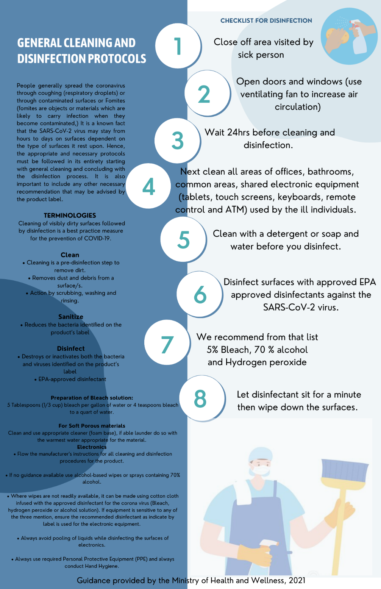

- See below inventory list of cleaning material, equipment and PPEs
ITEM
Insert list of cleaning material, equipment and PPE in stock.

- See below images of PPE and cleaning equipment
Insert images to correspond with your inventory

5) Ensure Clear and Consistent Communication
- Hotel policies
- The hotel has implemented all the safest measures in all efforts to reduce risk for guests and employees.

- Guest Communication Plan
- Draft email that will be sent to guests to explain protocols, reimbursements and expectations on booking
Sample email or insert the email used by your accommodation
Dear Guest,
Thank you for your interest in staying at ______________. We are happy to inform you that our accommodation is a Tourism Gold Standard Recognized Accommodation; which means we have implemented all measures to mitigate any risks for our guests and employees. Our accommodation employees have been trained to ensure your safety.
    - Note that you will be required to purchase a local travel insurance prior to or upon arrival to Belize. You can purchase this online at www.belizetravelinsurance.com
Thank you for your support and continued patience as we continue to work towards safely providing our services for you to enjoy our beautiful Belize. For more information on Belize’s entry requirements kindly visit: https://belizetourismboard.org/news-and-gallery/belize-covid-19-travel-updates/
Sincerely,

- See below information shared to guest that is contactless or can be sanitized.
(Insert image of laminated, digital or QR code of menu, welcome booklet in rooms, and any other information available that is contactless or can be sanitized.)

- Signage
Below are images of COVID-19 best practices signage that have been posted around the property. (Signs of social distancing, proper hand washing and symptoms for constant reminders to guest and staff. See annex for samples)

6) Install Hand Sanitizing Stations
- See below images at the entrance of the property of hand sanitizing stations, installed equipment with soap dispensers, sanitizer gel, single use towels, etc.
Insert images

7) Deploy New Technology
- See below description and images of payment process (credit card, website, online transfer, etc.)
Insert description and screenshots or images.

- See below description and images of check in process such as digital ticketing, email confirmations, etc.
Insert description and images.
8) Implement a Training Plan
- All employees will be trained on the new protocols implemented. Training offered will be logged using the template below (Insert log if you have your own template). Images will also be kept for records. (Insert images if available)
Sample Training Log
Name of Training | Date attended | Staff Names | Signature

Annex- Sample Signage
