Standard Operating Procedures for

[FSTV & Harvest Caye Entities]

Checklist for Gold Standard Recognition Program

Instructions: The below is a sample template to guide FSTV and Harvest Caye entities in developing the Standard Operating Procedures (SOP) to obtain Gold Standard Recognition. Gift Shops, Stores, Restaurant and Bars must complete sections in red and customize template to suit their Gift Shop. Once all sections are completed the plan must be submitted to entitygoldstandard@belizetourismboard.org
Name of Entity______________________________
Unit # of Entity______________________________
Type of Entity______________________________
Cruise Port of Entity______________________________

Declaration:
I hereby certify that all information provided in this application and plan is true, accurate and complete to the best of my knowledge. I have not withheld any information and understand any falsification is illegal and will disqualify this application.
Print Name of Gold Standard Manager_________________________________

Signature of Gold Standard Manager___________________________________

Print Name of General Manager/Owner________________________________

Signature of General Manager/Owner__________________________________

Date: _________________

-------------------------------------------------------------------------------------------------------------------------

1) Appoint a Tourism Gold Standard Manager
- Contact information of the appointed Gold Standard Manager
  - Name________________________________________
  - Phone________________________________________
  - Email_________________________________________
- Name of Alternate Gold Standard Manager
  - Name__________________________________________
  - Phone__________________________________________
  - Email___________________________________________

- Duties and responsibilities of the Gold Standard Manager
- Ensure that employees are aware of the procedures on how to handle a symptomatic case.
- Ensure that all logs are being followed.
- Conduct spot checks to ensure all protocols are being followed by employees
- Ensure all employees have PPE and disinfecting/ sanitizing equipment readily available
- Liaise with Ministry of Health on any symptomatic employees/guests and provide any logs necessary for contact tracing
- Ensure that entity Protocols are reviewed and modified as necessary
- Implement corrective actions when staff and guests are non-compliant with protocols
- List Others:
- ____________________________________________________________________________________________________________________________________________________________________________________________________________________________________________________________________________________________________________________________________________________

2) Implement Monitoring and Reporting
Monitoring
  - Employees:
    - If employee is sick, he/she should not come to work and report to Program Manager.
    - Every employee will be asked the following questions:
      - Have you been in close contact with a suspected or confirmed case of COVID 19?
      - Are your experiencing a cough, shortness of breath or sore throat
      - Have you had a fever in the last 48 hours?
      - Have you had a loss of smell or taste?
      - Have you had any vomiting or diarrhea in the last 24 hours?
      - Does anyone in your immediate household present these symptoms?
    - If multiple answers are yes, the employee will be isolated and the response plan will be activated.

  - Guests
    - Any guest that is observed to be symptomatic will be denied entry.
  - Security personnel and all staff will report any observations of guests and staff that appear to be symptomatic or non-compliant with protocols.
  - All will be observed for the following symptoms and reported:
    - Less serious symptoms
      - Fever
      - Dry cough
      - Headache
      - Conjunctivitis
      - Tiredness (prior to tour activities)
      - Loss of taste and smell
      - A rash on skin or discoloration of fingers or toes.
      - Aches and pains
      - Sore throat
      - Diarrhea
    - Serious symptoms
      - Difficulty breathing or shortness of breath
      - Chest pain or pressure
      - Loss of taste and smell
    - Any observation of symptoms will be communicated via the Ministry of Health and Wellness (MOHW) hotline 0-800-664- 2273.
    - For contact tracing queries at the district level the following numbers below can be utilized:
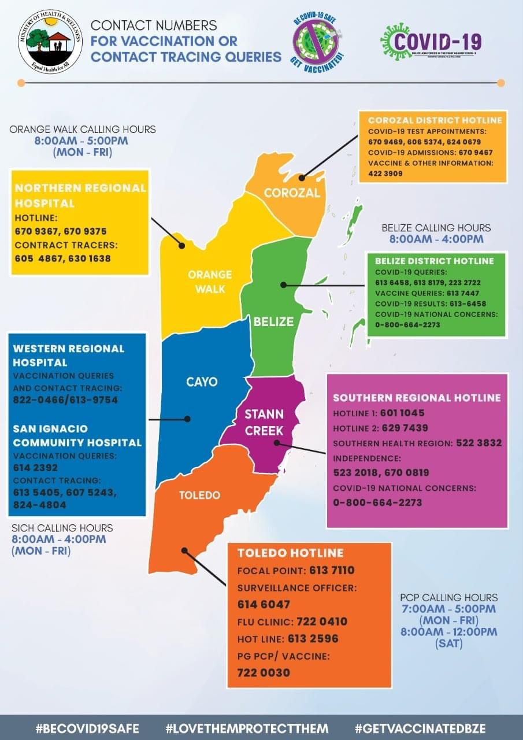

- For reference of reporting, the template below will be used to record any individual displaying symptoms, including elevated temperatures:
  - Templates of Log sheet used:
    - COVID-19 Symptomatic log
COVID-19 Symptomatic Log
Date | Guest or Employee name | Emergency contact information | Gender/Age | Symptoms observed | Place and time observed | Names of those in contact with symptomatic individual | Action taken

3) Implement Enhanced cleaning and Sanitization

- Cleaning and sanitization logs will be kept for all areas of the entity. Below are logs for tracking of enhanced cleaning and sanitization. For reference use below samples or insert image if you already have logs.

Sample Logs
  - Cleaning and sanitization for entity
Area being cleaned | Employee/ Company | Date | Time | Signature
Displays | John Doe | Dec 10, 2020 | 5:15pm
Reception Desk
Credit Card Machine
Counter Tops
Tables
Cash Register
Tables
Chairs
Light Switch

  - Cleaning and sanitization for back of house (kitchen)
Area being cleaned | Employee/ Company | Date | Time | Signature
Kitchen | John Doe | Dec 10, 2020 | 5:15pm

Area being cleaned | Employee/ Company | Date | Time | Signature
Dining | John Doe | Dec 10, 2020 | 5:15pm
Bar

- Below is the general guidance for how to conduct enhanced cleaning and sanitization. For reference below are some suggestions or insert images of checklist for each area to be cleaned.
Enhanced Cleaning Checklist for areas being cleaned:
TERMINOLOGIES
Cleaning of visibly dirty surfaces followed by disinfection is a best practice measure for the prevention of COVID-19 in the community setting.
Cleaning
•Cleaning is a pre-disinfection step to remove dirt.
• Removes dust and debris from a surface/s.
• Action by scrubbing, washing and rinsing.
Sanitize
• Reduces the bacteria identified on the product’s label
Disinfection
• Destroys or inactivates both the bacteria and viruses identified on the product’s label
• EPA-approved disinfectant

Entity Cleaning Checklist
Instructions
- Place work area warning sign.
- Pick up debris from floor.
- Empty trash cans/ashtrays and replace trash can liners, if needed. Wipe the outside.
- Clean high-touch point surfaces and other hard surfaces and disinfect as needed.
- Wipe and clean glass surfaces and windows, if needed.
- Clean counters.
- Tables & Chairs
- Clean POS screens.
- Clean all phones and any touch screens.
- Sweep and wet clean floors, if needed.

Entity HIgh touch areas that require attention:
- Door handles/knobs & handrails
- Phones & dial pads
- Trash can flips
- POS machines
- Counter tops
- Light switches
- Pens & Collaterals
Restaurant Cleaning Checklist
- Place work area warning sign.
- Pick up debris from floor.
- Empty trash cans and replace trash can liners, if needed.
- Clean high-touch point surfaces and other hard surfaces and disinfect as needed, especially after guests leave.
- Clean and check condition of any equipment before returning to use.
- Clean and check condition of all crockery, cutlery and glassware.
- Clean and check condition of storage boxes and cutlery trays.
- Sweep carpets or hard floors, if needed.
Note: Always ensure you wear correct Personal Protective Equipment

Restaurant HIgh touch areas that require attention:
- Dining tables, chairs/armrests and booths
- Door/drawer handles, push plates & handrails
- Coffee & Beverage stations
- Light switches
- Faucets
- Cupboards / Storage Areas
- Counter/desks (bar, entrance, etc.)
- Thresholds and hand railings
- Menus and menu holders (with plastic covers)
- Payment/POS Machine
- Trash receptacle touch points
- Hand Disinfectant Dispensers
- Collaterals & Pens

Kitchen Cleaning Checklist
Instructions:
- Pick up debris from floor.
- Empty trash cans and replace trash can liners, if needed. Wipe the outside.
- Clean high-touch point surfaces and other hard surfaces and disinfect as needed.
- Clean all crockery, cutlery, glassware and cooking utensils using soap and water.
- Clean and check condition of all food processing equipment (e.g. blender et c).
- Clean and check condition of refrigerators and freezers.
- Remove and dispose any rotten food.
- Sweep and wet clean, if needed
Note: Always ensure you wear correct Personal Protective Equipment

kitchen HIgh touch areas that require attention:
- Door and window handles & locks
- Switches & controls (e. g. thermometer)
- Food preparation surfaces, counters & tables
- Cooking utensils such as knives, spoons etc.
- Food Processing Equipment (e. g. blenders, cutting boards)
- Sinks & Washbasin faucets
- Hand soap dispenser buttons
- Hand towel dispenser handles
- Handles, drawers and cabinets of refrigerators & freezer
- Trash can flips
- Cleaning tools / buckets

- See below inventory list of cleaning material, equipment and PPEs
ITEM
Insert list of cleaning material, equipment and PPE in stock.

- See below images of PPE and cleaning equipment
Insert images to correspond with your inventory

- Disposal of waste
  - All employees will wear protective gloves and face masks when handling trash. Trash bins will be lined with bags and tied off securely when full.
  - All bags with possible contamination will be sealed in red bag and disposed separately.
4)Develop a Response Plan
- Employee must follow the following steps to deal with symptomatic person
Kindly insert step by step response plan based on your operations. See samples below
    - Anyone with symptoms will be denied entry into the insert type of entity here.
    - Employees who are symptomatic should not report to work and notify Program Manager.
    - Should staff become ill at the insert type of entity here; they will be sent home for medical attention.
    - Wait on report from insert cruise port of entity here Gold Standard Manager on how to proceed with employee/guest.
    - Disinfect and sanitize high touch point areas where case may have been in contact
- Any Customer that arrives with symptoms will be denied entry to the entity and advised to seek medical attention.

5) Ensure Clear and Consistent Communication

- Signage
  - Below are images of signage around the entrance area, at the cashier, inside entity, etc. Reference annex signs of social distancing, proper hand washing and symptoms for constant reminders to guest and staff. You can print and laminate these to stick in strategic locations of your entity.

6) Install Hand Sanitizing Stations
- Below are images of sanitization station at entrance: installed equipment with soap dispensers, sanitizer gel, single use towels, etc.
Insert images of sanitizing station

7) Deploy New Technology
- Below are images of payment process (credit card, sanitizing cash station, etc.)
Insert description and screenshots or images.

- Below are images of new technology to reduce physical contact (QR codes for pricing, laminated product booklet etc.) Insert description and images.

8) Implement a Training Plan
- All employees will be trained on the new protocols implemented. Training offered will be logged using the template below (Insert log if you have your own template). Images will also be kept for records. (Insert images if available)

Sample Training Log
Name of Training | Date attended | Staff Names | Signature

Annex- Sample Signage

