Standard Operating Procedures for

[Tour Operator Name]

9 Point Checklist for Gold Standard Recognition Program

The below is a sample template to guide Tour Operators in developing the Standard Operating Procedures (SOP) to obtain a Gold Standard Recognition.

Name of Tour Operator Company______________________________
Tour Operator license #______________________________________

1) Appoint a Tourism Gold Standard Manager
- Contact information of the appointed Gold Standard Manager
  - Name________________________________________
  - Phone________________________________________
  - Email_________________________________________
- Name of Alternate Gold Standard Manager
  - Name__________________________________________
  - Phone__________________________________________
  - Email___________________________________________

- Duties and responsibilities of the Gold Standard Manager
- Ensure that all tour guides have done the 5 training sessions
- Ensure that all tour guides know the procedures on how to handle a symptomatic case.
- Ensure that all logs are being followed on each tour
- Conduct spot checks on tours to ensure all protocols are being followed
- Ensure all guides have PPE and disinfecting/ sanitizing equipment
- Liaise with Ministry of Health on any symptomatic employee or guest, update Health app and provide any logs necessary for contact tracing
- Ensure that Tour Operator’s SOPs are reviewed and modified as necessary
- Implement corrective actions when staff and guests are non-compliant with protocols
- List Others:
- ____________________________________________________________________________________________________________________________________________________________________________________________________________________________________________________________________________________________________________________________________________________________________________________________________________________________________________________________________________________________________________________________________________________________________________________________________________________________________
- Dates of training done by Gold Standard Manager and Alternate
    - For reference click here for link to training videos
Training | Date and signature attended by Gold Standard Manager | Date and signature attended by Gold Standard Manager Alternate
Introduction to BTB Tourism Gold Standard for tour Operators
Tourism Gold Standard Program Manager training
Enhanced Safety Procedures for Tour Operators
Sanitizing and cleaning guidelines for Tour Operators
How to handle suspected case of COVID-19 among staff and guests
Other

2) Implement Monitoring and Reporting
- Monitoring
  - Employee checks:
    - If employee is sick, he should not come to work and report to Program Manager.
    - Every tour guide and employee’s temperature will be checked every day before a tour and logged at the staff entrance.
    - Every tour guide and employee will be asked the following questions:
      - Have you been in close contact with a suspected or confirmed case of COVID 19?
      - Are your experiencing a cough, shortness of breath or sore throat
      - Have you had a fever in the last 48 hours?
      - Have you had a loss of smell or taste?
      - Have you had any vomiting or diarrhea in the last 24 hours?
      - Does anyone in your immediate household present these symptoms?
    - If multiple answers are yes, the employee will be isolated and the response plan will be activated.

  - Guests
    - All guest’s temperatures will be taken before going on tour and logged.
    - Any symptomatic guest will be isolated and the response plan will be activated.
  - Vendors and supplier’s temperature will be taken and logged prior to entrance into office. No outside visitors will be allowed without being checked and logged entry.
  - Security personnel and all staff will report any observations of guests and staff that appear to be symptomatic or non-compliant with protocols.
  - All will be observed for the following symptoms and reported:
    - Less serious symptoms
      - Fever
      - Dry cough
      - Headache
      - Conjunctivitis
      - Tiredness (prior to tour activities)
      - Loss of taste and smell
      - A rash on skin or discoloration of fingers or toes.
      - Aches and pains
      - Sore throat
      - Diarrhea
    - Serious symptoms
      - Difficulty breathing or shortness of breath
      - Chest pain or pressure
      - Loss of taste and smell
    - Any symptom will be communicated via the Ministry of Health App, the hotline 0-800-MOH- CARE
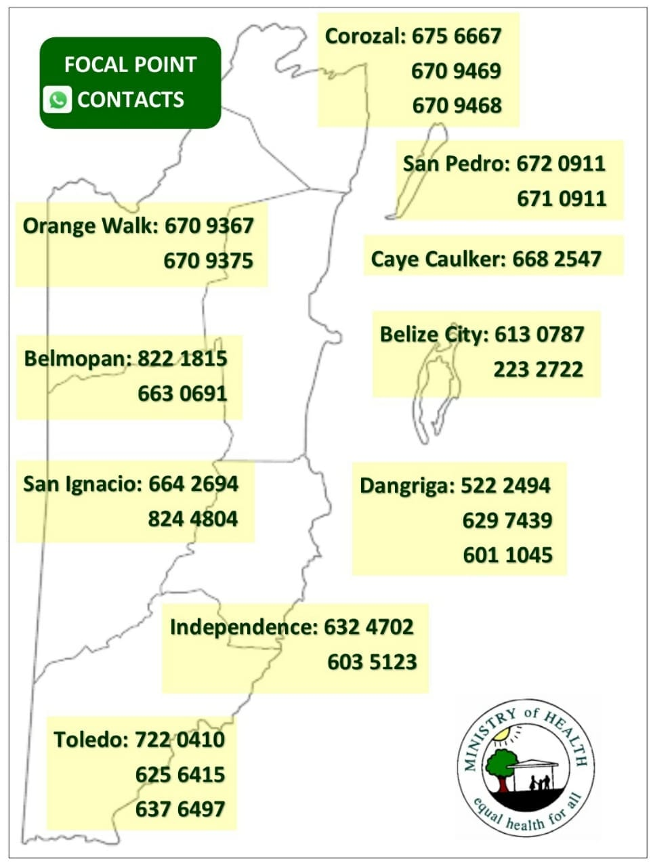

- For reference of reporting: Click here to download sample logs or attach image if you already have logs.
  - Logs attached:
    - Employee temperature log
    - Tour log template
    - COVID-19 symptomatic log template
    - Vendors and Suppliers tour log
    - Employee shift log template
    - Provide reservations and guest log template.
    - Other
3) Ensure Social Distancing Protocols
- Attached are pictures of social distancing in all of the below areas. For reference ensure to include x markers with tape/ stickers to show standing areas and signage for guests where applicable.
  - Place in strategic locations such as:
    - Reception area in office
    - Check in counters
    - Loading areas
    - Vehicle with partitions
    - Others that requires 6 ft distancing
Attach images
4) Implement Enhanced cleaning and Sanitization
- Staff
  - All employees will be provided a hand sanitizer for daily use
  - All staff will wear masks and/or face shields
  - All staff will wear gloves when handling equipment
- Below are logs for tracking of enhanced cleaning and sanitation. For reference use below samples or attach image if you already have logs.

  - Cleaning and disinfecting time log fleet
Vehicle | Employee | Date | Time | Signature
Ex- Vehicle C-1967 | John Doe | Dec 10, 2020 | 5:15pm

  - Cleaning disinfection equipment
Equipment | Employee/ Company | Date | Time | Signature
Snorkel masks | John Doe | Dec 10, 2020 | 5:15pm

  - Cleaning disinfection office space
Office | Employee/ Company | Date | Time | Signature
Reception desk | John Doe | Dec 10, 2020 | 5:15pm
Loading area
Bathroom

- Below is a checklist of high touch point of different areas and how to clean each respectively. For reference below are some suggestions or attach images of checklist for each area to be cleaned.
  - Office Area-
AREA | HOW TO CLEAN | EQUIPMENT NEEDED | Frequency | CHECK IF COMPLETED
Counter check in areas | Designated rag with bleach and water, make sure bleach mixture is no more than 3 days old……. | Gloves, rag, spray bottle with mixture of 2 parts water 1 part bleach | After every guest
Computer, credit card machines, keyboard, mouse, calculator, etc
Door knobs
Phone system
Credit Card system
Waiting area chairs
Check in counters
Other

  - Loading areas
AREA | HOW TO CLEAN | EQUIPMENT NEEDED | Frequency | CHECK IF COMPLETED
Seating areas | Designated rag with bleach and water, make sure bleach mixture is no more than 3 days old, or spray with chemicals…. | Gloves, rag, spray bottle with mixture of 2 parts water 1 part bleach | After every guest
other
  - Transportation vehicle
AREA | HOW TO CLEAN | EQUIPMENT NEEDED | Frequency | CHECK IF COMPLETED
Door handles | Designated rag with bleach and water, make sure bleach mixture is no more than 3 days old, | Gloves, rag, spray bottle with mixture of 2 parts water 1 part bleach | After every guest use
Seats | Sanitizing interior with warm water and soap, scrub then vacuum upholstery. If seats have plastic, then a bleach solution mixture can be sprayed and wiped down. | Gloves, soap, water, bucket, scrub, rag, vacuum; or bleach, rag, gloves | After every guest use
Windows
Window buttons
Air condition vent and controls
Other

  - Transportation boats
AREA | HOW TO CLEAN | EQUIPMENT NEEDED | Frequency | CHECK IF COMPLETED
Seating area | Hose down with soap and water, add bleach mixture for added sanitization for exterior. | Gloves, rag, spray bottle with mixture of 2 parts water 1 part bleach. | After every guest use
Captain’s Chair
Steering wheel and driver controls
Handle rails
Cooler
Cushions boat seat
Other

  - Restroom
AREA | HOW TO CLEAN | EQUIPMENT NEEDED | Frequency | CHECK IF COMPLETED
Door handle | Hose down with soap and water, add bleach mixture for added sanitization | Gloves, rag, spray bottle with mixture of 2 parts water 1 part bleach | Hourly
Sink and faucet
Floor
Soap dispenser
Toilet paper dispenser
Toilet
Light switches

  - Equipment
AREA | HOW TO CLEAN | EQUIPMENT NEEDED | Frequency | CHECK IF COMPLETED
Tubes | Hose down with soap and water, add bleach mixture for added sanitization | Gloves, rag, spray bottle with mixture of 2 parts water 1 part bleach | After every guest use
Dive tanks | Note details in annex.
Snorkel masks
Fishing rods
Other

- Provide inventory list of cleaning material and PPEs
ITEM | QUANTITY
Surgical Masks
Gloves(box of 50 pairs)
Bleach1 gallon | 5
Baceteria killing agents chemicals
Sprayers

- Attached are images of PPE and cleaning equipment
Attach images

- Disposal of waste
  - All employees will wear protective gloves and face masks when handling trash. Trash bins will be lined with bags and tied off securely when full.
  - All bags with possible contamination will be sealed in red bag and disposed separately.

5)Develop a Response Plan
- All staff must follow the following steps to deal with symptomatic guest
  - Check in at the office
    - isolate guest at designated location at site or isolate at____________________________________________
    - contact the Program manager (Program Manager will contact Hotel, MOH or Cruise Port.)
    - put symptomatic guest into separate vehicle to transport to hotel/ cruise line or if symptoms are severe organize with MOH to be taken to medical facility
    - update logs of COVID-19 case
    - disinfect and sanitize vehicles and equipment used on tour
    - log cleaning of all vehicles and equipment

  - On tour
    - isolate guest at designated location at site or isolate at____________________________________________
    - contact the Program manager (Program Manager will contact Hotel, MOH or Cruise Port.)
    - put symptomatic guest into separate vehicle to transport to hotel/ cruise line or if symptoms are severe organize with MOH to be taken to medical facility
    - update logs of COVID-19 case
    - disinfect and sanitize vehicles and equipment used on tour
    - log cleaning of all vehicles and equipment
  - Closest medical facility identified
    - _________________________________________
    - _________________________________________
  - Additional notifications
    - Embassy
    - Hotels

  - PPE to be used when dealing with a symptomatic or positive case

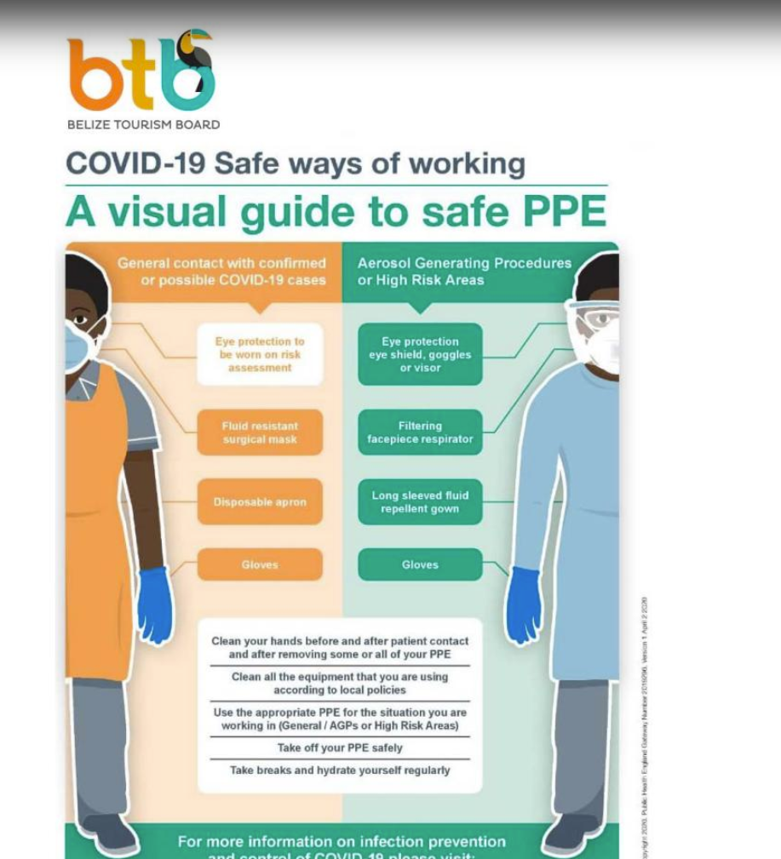

6)Ensure Clear and Consistent Communication
- Publicized Standard Operating Procedure can be found on website ________________________________________
- Tour policies
  - All tours will be executed with the safest measures in all efforts to reduce risk for guests and employees.
  - Masks required at all times, with only exceptions:
    - On a high intensity tour where the guide is 6 feet apart. For example- hiking, rappelling.
    - Snorkeling
    - Once guest is seated in a restaurant to eat
    - Beach once sufficient distance is maintained from other guests.
  - Booking will be flexible to accommodate payment reimbursements should a guest become symptomatic prior to tour and not able to take the tour.

- Guest Communication Plan
  - Draft email that will be sent to guests to explain protocols, reimbursements and expectations on tour
Sample email
Dear Guest,
Thank you for your interest in taking a ______________tour with us. We are happy to inform you that our company is a Tourism Gold Standard Recognized Tour Operator Company; which means we have implemented all measures to mitigate any risks for our guests and employees. All our tours and sites have been designated within the safe corridor (as seen in image below) can be found in attached brochure.
What to expect on tour?
    - All tours will be guided by our expert and trained tour guides
    - Expect to have your tempreture tested upon pick up at the cruise port or hotel
    - Masks required at all times, with only exceptions:
        - On a high intensity tour where the guide is 6 feet apart. For example- hiking, rappelling.
        - Snorkeling
        - Once guest is seated in a restaurant to eat
        - Beach once sufficient distance is maintained from other guests.
    - Booking will be flexible to accommodate payment reimbursements should you become symptomatic prior to tour and not able to take the tour.
    - Must sign waiver accepting terms and conditions of tour
Thank you for your support and continued patience as we continue to work towards safely providing our services for you to enjoy our beautiful Belize.
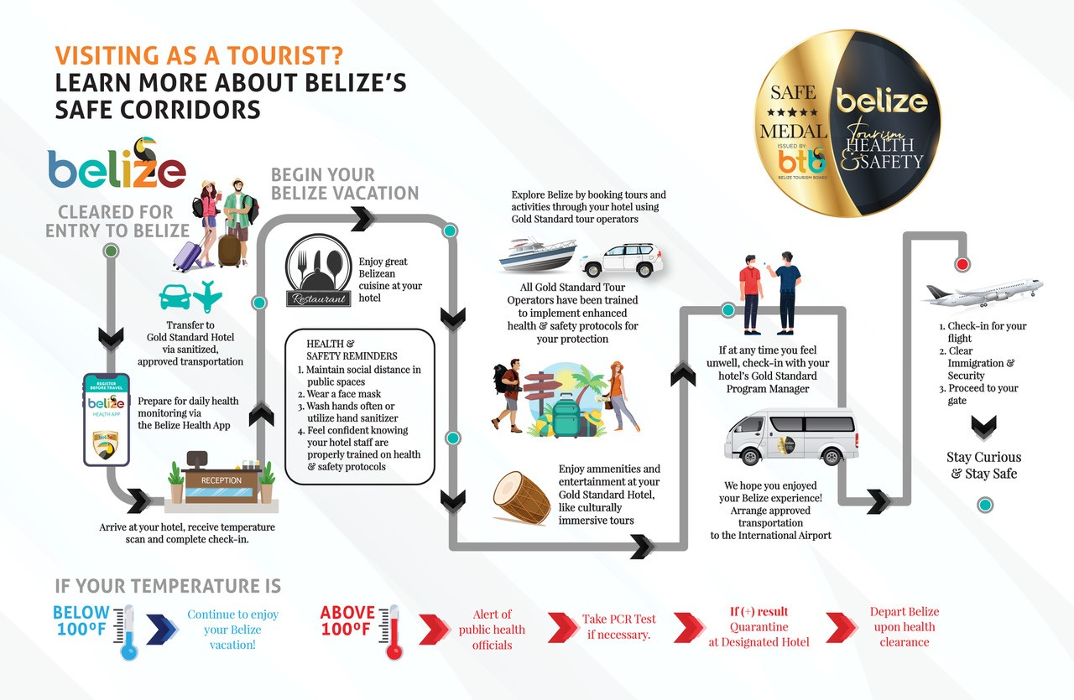
Sincerely,

  - Sample disclaimer- penalties of non-compliance with masks, cost of quarantine if positive, or any other liability clauses
Attach image

  - Attach image of laminated tours, digital flyer or marketing material used to show guests information that is contactless or can be sanitized.
Attach image

  - Attach images of all social media, website, email etc of platforms used to display protocols and information.
Attach image

  - Platforms used to reinforce the message to guests: E.g. Facebook, Online booking etc.
Attach image

- Employee Communication below has been sent to all staff.
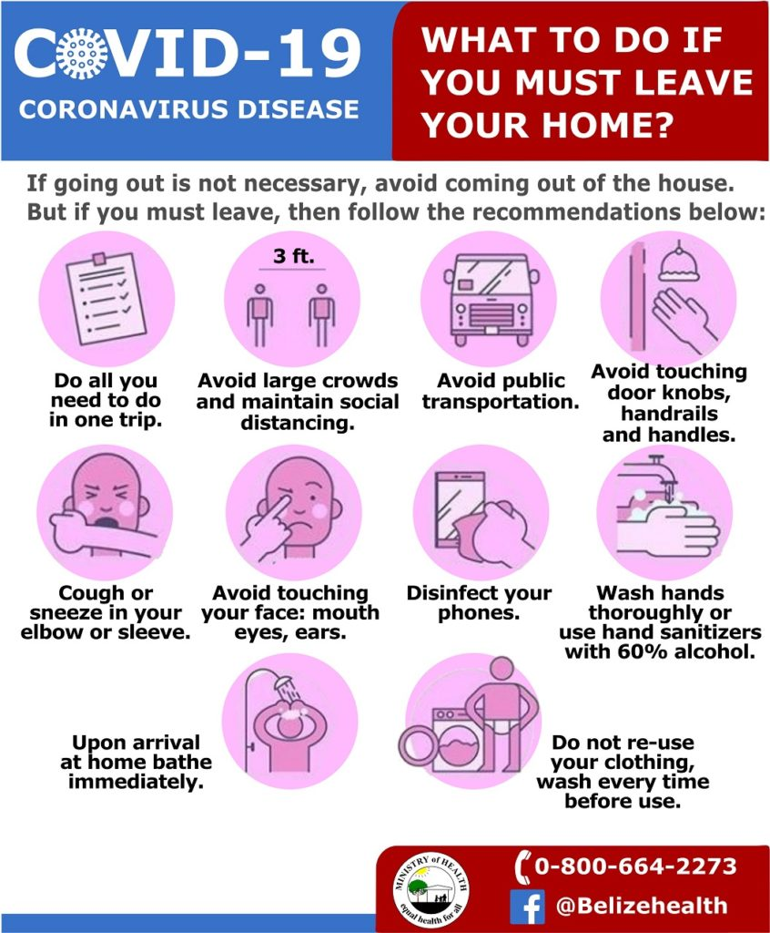

- Signage
  - Below are images of signage around the tour office and vehicles. Reference annex signs of social distancing, proper hand washing and symptoms for constant reminders to guest and staff.

Attach images

7)Install Sanitizing Stations
- Attached are images of sanitizing stations installed equipment with soap dispensers, sanitizer gel, single use towels, etc
Attach images
- Attached are images of sanitizing and adequate in each vehicle/ vessel.

Attach images

8)Deploy New Technology (If applicable)
- Attached are images of payment process (credit card, pre check-in credit card, website, online transfer, etc)

- Attached are images of pre-check in process, digital ticketing, etc.
9)Implement a Training Plan
- Training logs and images

Training | Date attended staff | Signature
Introduction to BTB Tourism Gold Standard for tour Operators
Tourism Gold Standard Program Manager training
Enhanced Safety Procedures for Tour Operators
Sanitizing and cleaning guidelines for Tour Operators
How to handle suspected case of COVID-19 among staff and guests
Other

Annex

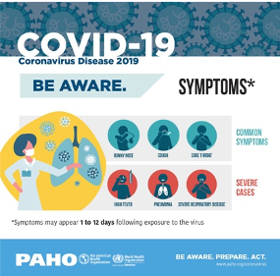
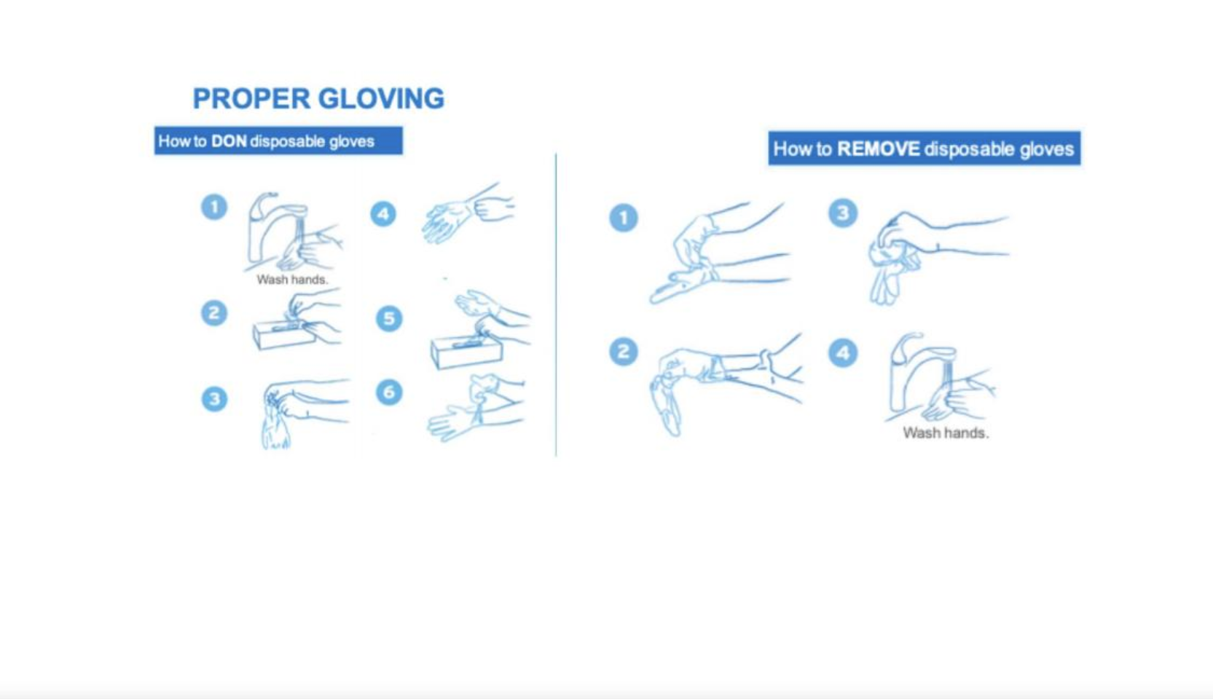

How to clean Scuba Equipment?
https://www.diversalertnetwork.org/emailview/landing/coronavirus/gearDisinfection/index.html

