Standard Operating Procedures for

Water Taxi Operations (Name of Company)

9 Point Checklist for Gold Standard Recognition

The below is a sample template to guide Water Taxi Operators in developing the Standard Operating Procedures (SOP) to obtain a Gold Standard Recognition.

Declaration:
I hereby certify that all information provided in this application and plan is true, accurate and complete to the best of my knowledge. I have not withheld any information and understand any falsification is illegal and will disqualify this application.
Print Name of Gold Standard Manager_________________________________
Signature of Gold Standard Manager___________________________________
Name/ Address of the Water Taxi Company_____________________________
_________________________________________________________________
Date: ____________________________________________________________
Applicants must submit below:
- Signed declaration above
- Standard Operating Procedure including the 9-point checklist
- Copy of Belize Port Authority Registration Certificate
- Copy of valid Seaworthiness Certificate for each vessel
- List all the destinations where loading of passengers is conducted:
  - _________________________________
  - _________________________________
  - _________________________________
  - _________________________________

Submit to: entitygoldstandardapplication@belizetourismboard.org

1) Appoint a Tourism Gold Standard Manager
- Contact information of the appointed Gold Standard Manager
  - Name________________________________________
  - Phone________________________________________
  - Email_________________________________________
  - Social Security #________________________________
- Name of Alternate Gold Standard Manager
  - Name__________________________________________
  - Phone__________________________________________
  - Email___________________________________________
  - Social security #__________________________________

- Duties and responsibilities of the Gold Standard Manager
- Ensure that all boat captains and crew have done the 5 training sessions below:
-Introduction to Tourism Gold Standards for Water Taxi’s, Tourism Gold Standard Program Manager training, Enhanced Safety Procedure for Boat Captain and Crew, Sanitizing and cleaning guidelines for boat captain and crew, and how to handle a suspected case of COVID-19 among staff and passengers.
- Ensure that all boat captains and crew know the procedures on how to handle a symptomatic case.
- Ensure that all logs are being followed on each trip/run
- Conduct spot checks on trips/runs to ensure all protocols are being followed
- Ensure all guides have PPE and disinfecting/ sanitizing equipment
- Liaise with Ministry of Health on any symptomatic employee or passenger, and provide any logs necessary for contact tracing
- Ensure that all vessels and equipped with hand sanitizer for public consumption
- Ensure that the Water Taxi’s SOPs are reviewed and modified as necessary
- Ensure that all vessels operating are following by the guidelines provided by the Government of Belize as it pertains to capacity limitations of passengers being transported.
- Implement corrective actions when staff and passengers are non-compliant with protocols
- List Others:
- ________________________________________________________________________________________________________________________________________________________________________________________________________________________________________________________________________________

- Dates of training done by Gold Standard Manager and Alternate
    - For reference click here for link to training videos
Training | Date and signature attended by Gold Standard Manager | Date and signature attended by Gold Standard Manager Alternate
Introduction to BTB Tourism Gold Standard for Boat captains and Crew | Insert signature and dates attended in this column | Insert signature and dates attended in this column
Tourism Gold Standard Program Manager training
Enhanced Safety Procedures for Boat captains and crew
Sanitizing and cleaning guidelines for Boat captains and crew
How to handle suspected case of COVID-19 among staff and passengers
Other

2) Implement Monitoring and Reporting
Monitoring
  - Employee checks:
    - If employee is sick, he should not come to work and report to Program Manager.
    - Every employee’s temperature will be checked every day before a trip/run and logged at the staff entrance.
    - Every employee will be asked the following questions:
      - Have you been in close contact with a suspected or confirmed case of COVID 19?
      - Are your experiencing a cough, shortness of breath or sore throat
      - Have you had a fever in the last 48 hours?
      - Have you had a loss of smell or taste?
      - Have you had any vomiting or diarrhea in the last 24 hours?
      - Does anyone in your immediate household present these symptoms?
    - If multiple answers are yes, the employee will be isolated and the response plan will be activated.

  - Passengers
    - All passenger’s temperatures will be taken before getting on their scheduled boat.
    - Any passenger with temperature over 100F must be logged and treated as a symptomatic passenger.
    - Any symptomatic passenger will be isolated and the response plan will be activated.
  - Vendors and supplier’s temperature will be taken and logged prior to entrance into office. No outside visitors will be allowed without being checked and logged entry.
  - Security personnel and all staff will report to the Program Manager any observations of passengers and staff that appear to be symptomatic or non-compliant with protocols.
  - All will be observed for the following symptoms and reported:
    - Less serious symptoms
      - Fever
      - Dry cough
      - Headache
      - Conjunctivitis
      - Tiredness (prior to boarding activities)
      - Loss of taste and smell
      - A rash on skin or discoloration of fingers or toes.
      - Aches and pains
      - Sore throat
      - Diarrhea
    - Serious symptoms
      - Difficulty breathing or shortness of breath
      - Chest pain or pressure
      - Loss of taste and smell
    - Any symptom will be communicated via the Ministry of Health hotline 0-800-MOH- CARE
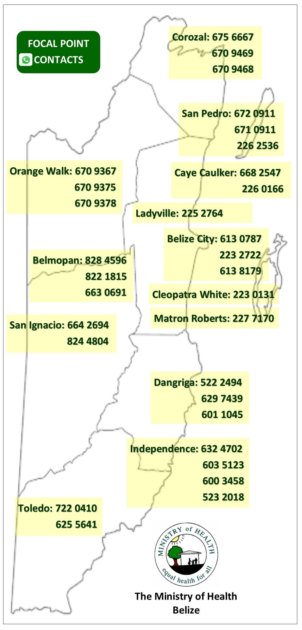

- Below reporting logs must be implemented.

  - Templates of Log sheets used:
    - Manifest log
    - Employee temperature log
    - COVID-19 symptomatic log template
    - Vendors and Suppliers Temperature log
    - Employee shift log template
    - Other

I agree to use the below sample logs (Check box if you agree and ensure to have logs printed and in use for inspection)

  - Manifest Log (inclusive of employees)
Date | Time | Embarkation | End destination | First Name | Last Name

  - Employee Temperature and monitoring logs
Date | Time | Employee Name | Recorded Temperature | Screener Name | Comments

  - Covid-19 symptomatic log
Date | Guest or Employee Name | Email address | Emergency Contact info | Gender | Age | Recorded  Temp | Symptoms | Time observed | Action Taken

  - Visitor log
Date | Time | Visitor Name | Employee who attended visitor | Recorded Temperature | Screener name | Comments

  - Employee shift logs
Date | Time arrived | Time out from departure | Time in from return | Signature of employee

If your logs are different, please insert pictures below:

3) Ensure Social Distancing Protocols
- Insert pictures of social distancing in all of the below areas. For reference ensure to include x markers with tape/ stickers to show standing areas and signage for passengers where applicable.
  - Place in each destination loading location where applicable:
    - Reception area in office
    - Check in counters
    - Loading areas
    - Tenants
    - Other areas that requires 6 ft. distancing
- Insert images below of your facility meeting the social distancing requirements
Area | Picture
For example, All relevant areas-  Reception/ ticketing Area- San Pedro  Caye Caulker | 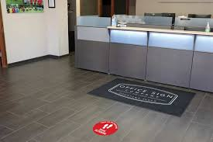  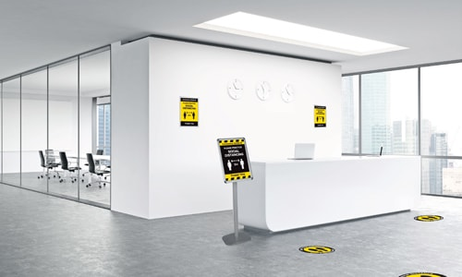
Loading areas on dock
On each vessel
Show signage of social distancing requirement at each location

4) Implement enhanced cleaning and sanitization
- Staff
  - All employees will be provided a hand sanitizer for daily use
  - All staff will wear masks and/or face shields
  - All staff will wear gloves when handling equipment
- Below are logs for tracking of enhanced cleaning and sanitation.
I agree to use the below sample logs (Check box if you agree and ensure to have logs printed for inspection)

Sample Logs
  - Daily cleaning and disinfecting time log fleet (ensure to log all vessels)
Vessel | Employee | Date | Time | Cleaned with | Signature
Ex- Boat Name | John Doe | Dec 10, 2020 | 5:15pm | Use of soap, anti-bacterial cleaning agent, bleach solution, etc

  - Daily cleaning and disinfection log for equipment
Equipment | Employee/ Company | Date | Time | Cleaned with | Signature
Cargo cart | John Doe | Dec 10, 2020 | 5:15pm | Use of soap, anti-bacterial cleaning agent, bleach solution, etc
Other list here

  - Daily cleaning and disinfection log for office space
Office | Employee/ Company | Date | Time | Cleaned with | Signature
Reception/ ticketing desk | John Doe | Dec 10, 2020 | 5:15pm | Use of anti-bacterial cleaning agent, bleach solution, etc
Loading area
Bathroom
Other list here

If your logs are different, please insert pictures below:

- Below is a checklist of high touch point of different areas and how to clean each respectively before completing cleaning log.
Sample high touch point checklists for cleaners:

  - Office Area-
AREA | HOW TO CLEAN | EQUIPMENT NEEDED | Frequency | CHECK IF COMPLETED
Counter check in areas | Designated rag with bleach and water, make sure bleach mixture is no more than 3 days old……. | Gloves, rag, spray bottle with mixture of 2 parts water 1 part bleach | After every passenger
Computer, , keyboard, mouse, calculator, etc | Insert “How to clean” description here for the respective area as per the example above. | Insert “Equipment needed” here for the respective area as per the example above. | Insert “frequency” description for the respective area as per the example above.
Door knobs
Phone system
Credit Card system
Waiting area chairs
Check in counters
Other

  - Loading areas
AREA | HOW TO CLEAN | EQUIPMENT NEEDED | Frequency | CHECK IF COMPLETED
Seating areas | Designated rag with bleach and water, make sure bleach mixture is no more than 3 days old, or spray with chemicals…. | Gloves, rag, spray bottle with mixture of 2 parts water 1 part bleach | After every passenger
other

  - Transportation boats
AREA | HOW TO CLEAN | EQUIPMENT NEEDED | Frequency | CHECK IF COMPLETED
Seating area | Hose down with soap and water, add bleach mixture for added sanitization for exterior. | Gloves, rag, spray bottle with mixture of 2 parts water 1 part bleach. | After every passenger use
Captain’s Chair
Steering wheel and driver controls
Handle rails
Cooler
Cushions boat seat
Other

  - Restroom
AREA | HOW TO CLEAN | EQUIPMENT NEEDED | Frequency | CHECK IF COMPLETED
Door handle | Hose down with soap and water, add bleach mixture for added sanitization | Gloves, rag, spray bottle with mixture of 2 parts water 1 part bleach | Hourly
Sink and faucet
Floor
Soap dispenser
Toilet paper dispenser
Toilet
Light switches

  - Equipment
AREA | HOW TO CLEAN | EQUIPMENT NEEDED | Frequency | CHECK IF COMPLETED
Cargo cart | Spray with disinfecting solution on all cargo prior to loading | Gloves, rag, spray bottle with solution | Each trip
If your logs are different, please insert pictures below:

- Disposal of waste
  - All employees will wear protective gloves and face masks when handling trash. Trash bins will be lined with bags and tied off securely when full.
  - All bags with possible contamination will be sealed in red bag and disposed separately.

5) Develop a Response Plan
- All staff must follow the following steps to deal with symptomatic passenger/ employee
  - No one with symptoms will be allowed into the Water Taxi facilities. Should staff or guest become ill at the facility, the following steps will be taken:

  - At the reception/ ticketing office
    - isolate passenger at ____________________________________________
    - contact the Program Manager (Program Manager will contact Family, Hotel, MOH or Cruise Port.)
    - if symptomatic passenger is a local and can call someone to pick them up have them do so, if symptoms are severe organize with Local medical facility to have them be taken to medical facility
    - if the symptomatic passenger is not a local put them into separate vehicle to transport to hotel/ cruise line or if symptoms are severe organize with MOH to be taken to medical facility
    - update logs of Symptomatic COVID-19 case
    - disinfect and sanitize area where passenger or staff were in contact
    - log disinfecting of all areas

  - On trip/run
    - isolate passenger at designated location on the vessel
    - boat captain to contact the Program manager (Program Manager will contact medical facility in region to be at dock for medical assistance)
    - upon arrival, put symptomatic passenger into separate vehicle to transport to hotel/ cruise line or if symptoms are severe organize with MOH to be taken to medical facility
    - disinfect and sanitize area where passenger or staff was in contact
    - log disinfecting of the vessel

- Closest medical facility identified for each destination (Insert name and contact information)
    - _________________________________________
    - _________________________________________
    - _________________________________________
    - _________________________________________

- Additional notifications- Gold Manager(s) will assist guests with contacting their local diplomatic mission. This is often done to register their location and situation in a country if necessary. Should the guest(s) choose to contact the embassy directly they are free to use the local line. Should guest(s) request that the mission be contacted on their behalf then Management will request an electronic copy of their ID for verification purposes.

- See below inventory list of cleaning material, equipment and PPEs in stock
ITEM | QUANTITY
Insert list of cleaning material, equipment and PPE in stock. | Insert corresponding quantity for each item listed.
Surgical Masks
Gloves(box of 50 pairs)
Bleach1 gallon | 5
Baceteria killing agents chemicals

- See below images of PPE and cleaning equipment currently in stock
Insert images to correspond with your inventory

6) Ensure Clear and Consistent Communication
- Travel policies
- All trips/runs will be executed with the safest measures in all efforts to reduce risk for passengers and employees.
- Masks required at all times.
- Booking will be flexible to accommodate payment reimbursements should a passenger become symptomatic prior to their trip.

- Passenger Communication Plan
- Draft signage that will be posted in offices, waiting rooms, and online that explains our protocols, reimbursements and expectations.
Sample letter:
Dear Passenger,
Thank you for choosing to travel with us. We are happy to inform you that our company is a Tourism Gold Standard Recognized Water Taxi Company; which means we have implemented all measures to mitigate any risks for our passengers and employees. What to expect?
    - All trips/runs will be executed by our expert and trained crew.
    - Expect to have your temperature tested before your board our vessels.
    - Masks are required at all times.
    - Vessels will be operating at reduced capacities to allow for social distancing between non family groups.
    - Booking will be flexible to accommodate payment reimbursements should you become symptomatic prior to your trip.
Thank you for your support and continued patience as we continue to work towards safely providing our services for you to enjoy our beautiful Belize.
Sincerely,
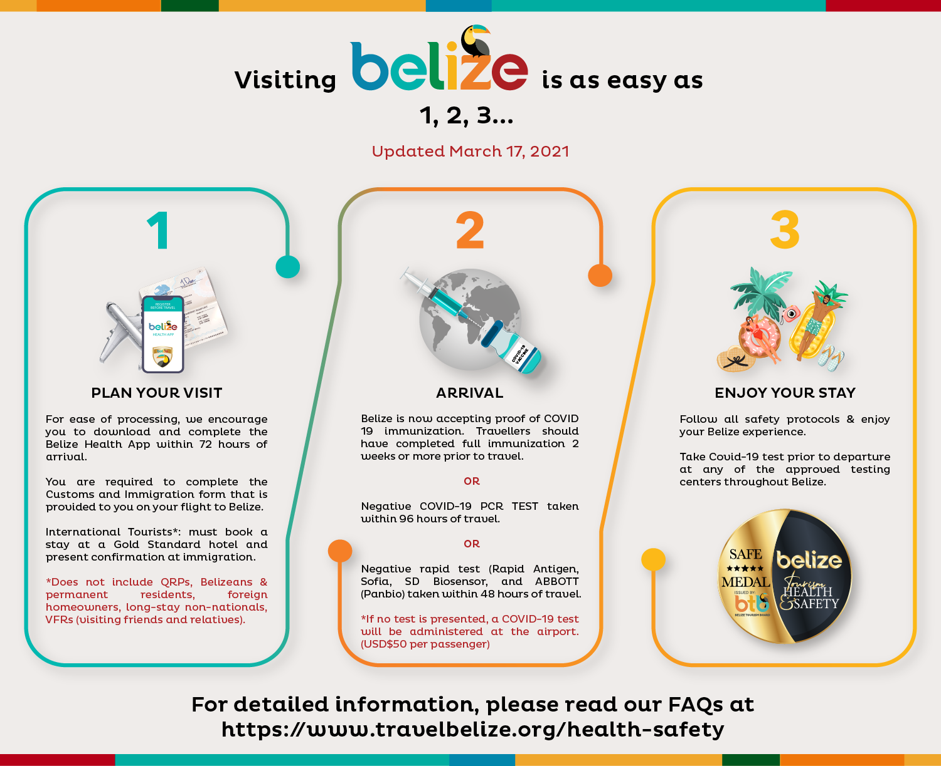

- Sample disclaimer- penalties of non-compliance with masks, cost of quarantine if positive, or any other liability clauses
Insert image

- Employee Communication below has been sent to all staff or provided during training sessions.

- Platforms used to reinforce the message to passengers: E.g. Email, Facebook, Online booking etc.
Insert image or url link- For example
- Signage
- Below are images of best practices signage around the office, vehicles, boats, loading areas (where applicable). (Signs of, proper hand washing, wearing of mask and symptoms for constant reminders to passenger and staff.

Area | Picture
Signage of best practices in bathroom
Signage of best practices in the reception/office area, loading area and vessels
Signage of best practices in loading areas and vessels
Other

Insert images installed in all relevant areas.

7) Install Sanitizing Stations
- See below images of sanitizing stations (installed equipment with soap dispensers, sanitizer gel, single use towels, etc.) in all relevant areas (Office, Loading Area, Restroom, Vessel, Vehicle, etc.)
Insert images and list location of sanitizing station
Area | Picture or URL link
Example- Belize City terminal- office area | 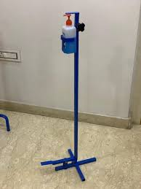

8) Deploy New Technology
- See below description and images of payment process (credit card, pre check-in credit card, website, online transfer, digital ticketing, email confirmations, digital schedules/ pricing, etc.)
Insert description and screenshots or images.

Contactless points | Picture
Online ticket sales/ Check in | 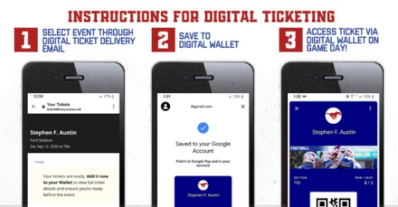
Cashless payment methods
QR code for schedules | 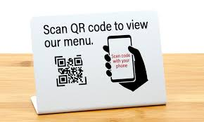
Digital Boarding passes

9) Implement a Training Plan
- All employees will be trained on the new protocols implemented. Training offered will be logged using the template below (Insert log if you have your own template). Images will also be kept for records. (Insert images if available)
Sample Training Log
Training | Date attended | Staff Names | Signature

Annex- Sample Signage
