TOURISM GOLD STANDARD CERTIFICATION
APPLICATION CHECKLIST Fort Street Tourism Village
For Gift Shops, Stores and Other Shops
Declaration:
I hereby certify that all information provided in this application and plan is true, accurate and complete to the best of my knowledge. I have not withheld any information and understand any falsification is illegal and will disqualify this application.
Print Name of Gold Standard Manager_________________________________
Signature of Gold Standard Manager___________________________________
Name/ Address of the Gift Shop_____________________________________
Date: ____________________________________________________________
Applicants must also submit copies of Company Registry, Trade License or Incorporation Certificate along with their submission. Below checklist must be submitted in the plan to: entitygoldstandardapplication@belizetourismboard.org

Shops/Stores
Program Manager
 |  | Yes | NO | COMMENTS
1. | Name of Program Manager has been submitted
2. | Name of Program Manager Alternate has been submitted
3. | List of duties and job responsibilities of program manager have been submitted
4. | Has both Program Manager and Alternate viewed the 3 Gift Shop Gold Standard Webinars
TOTAL |  | 0/4

Implement Monitoring & Reporting
Did the Gift Shop provide the following at the time of submission?
 |  | YES | NO | COMMENTS
1. | Covid-19 Symptomatic Log
TOTAL |  | 0/1

Ensure Social Distancing Protocols
Did the Gift Shop provide the following at the time of application?
 |  | YES | NO | COMMENTS
1. | Images of Social distancing signage at entrance area
2. | Images of social distancing floor markings inside the gift shop
TOTAL |  | 0/2

Implement Enhanced Cleaning & Sanitization Procedures
Did the Gift Shop provide the following at the time of application?

 |  | YES | NO | COMMENTS
1. | Cleaning Checklist for High Touch Surfaces
TOTAL |  | 0 /1

Develop a Response Plan
Did the Gift Shop provide the following at the time of application?
 |  | YES | NO | COMMENTS
1. | Provide list of steps to deal with symptomatic employee & guest
TOTAL | 0 /1

Ensure Clear & Consistent Communication
Did the Gift Shop provide the following at the time of application?
 |  | YES | NO | COMMENTS
1. | Provide images of signage installed throughout the shop with COVID-19 best practices, Health and Safety protocol signage (hand washing, mask wearing, etc)
TOTAL |  | 0/1

Install Sanitizing Stations
Did the Gift Shop provide the following at the time of application?
 |  | YES | NO | COMMENTS
1. | Hand sanitizing or hand washing stations at Entrance
2. | Hand sanitizing or hand washing stations at Inside Gift Shop
3. | Hand sanitizing or hand washing stations at Cashier
TOTAL |  | 0 /3

Deploy New Technology
Did the Gift Shop provide the following at the time of application?
 |  | YES | NO | COMMENTS
1. | Images of contactless payment methods, credit card or sanitizing of cash stations, etc
TOTAL |  | 0 /1

Implement a Training Plan
Did the Gift Shop provide the following at the time of application?
 |  | YES | NO | COMMENTS
1. | Training all staff and new staff
TOTAL |  | 0 /1

Health and Safety Protocols for

[FSTV Shops]

Checklist for Health and Safety Protocols

The below is a sample template to guide Gift Shops in developing the Health and Safety Protocols to open in the safe corridor. Please fill everything in red and attach images where necessary.
Updated June 25, 2021

Name of Shop/store______________________________________________
Unit # of Shop/store _____________________________________________
Cruise Port of Gift Shop_____________________________________________

1) Appoint a Tourism Gold Standard Manager
- Contact information of the appointed Manager
  - Name________________________________________
  - Phone________________________________________
  - Email_________________________________________
- Contact information of the appointed Alternate Manager
  - Name________________________________________
  - Phone________________________________________
  - Email_________________________________________
- Duties and responsibilities of the Manager/ Supervisor
- Ensure that employees have done health and safety training sessions
- Ensure that employees are aware of the procedures on how to handle a symptomatic case.
- Conduct spot checks to ensure all protocols are being followed by employees
- Ensure all employees have PPE and disinfecting/ sanitizing equipment
- Ensure that shop/store Protocols are reviewed and modified as necessary
- Implement corrective actions when staff and guests are non-compliant with protocols
- List Other Duties & responsibilities:
- ________________________________________________________________________________________________________________________________________
- Dates of training done by Gold Standard Manager and Alternate
*Training videos are posted on www.belizetourismboard.org
Training | Date attended by Gold Standard Manager | Name | Signature | Date attended by Alternate Manager | Name | Signature
Introduction to the Tourism Gold Standard Program
Enhanced Safety Protocols for Gift Shops
Cleaning and Sanitization guidelines for Gift Shops
Other

2) Implement Monitoring and Reporting
- Monitoring
  - Employee checks:
    - If employee is sick, he should not come to work and report to Manager.
    - Every employee’s temperature will be checked every day before a shift at the port entrance.
    - Every employee will be asked the following questions:
      - Have you been in close contact with a suspected or confirmed case of COVID 19?
      - Are your experiencing a cough, shortness of breath or sore throat
      - Have you had a fever in the last 48 hours?
      - Have you had a loss of smell or taste?
      - Have you had any vomiting or diarrhea in the last 24 hours?
      - Does anyone in your immediate household present these symptoms?
    - If multiple answers are yes, the employee will be asked to home and seek medical attention.

  - Guests
    - Any guest that is observed to be symptomatic will be denied entry.
  - Security personnel and all staff will report any observations of guests and staff that appear to be symptomatic or non-compliant with protocols.
  - All will be observed for the following symptoms and reported:
    - Less serious symptoms
      - Fever
      - Dry cough
      - Headache
      - Conjunctivitis
      - Tiredness (prior to tour activities)
      - Loss of taste and smell
      - A rash on skin or discoloration of fingers or toes.
      - Aches and pains
      - Sore throat
      - Diarrhea
    - Serious symptoms
      - Difficulty breathing or shortness of breath
      - Chest pain or pressure
      - Loss of taste and smell
    - Any symptom will be communicated via the FSTV Port Gold Standard Manager

- For reference of reporting: Note below sample logs or attach image if you already have logs.
  - Logs attached:
    - COVID-19 symptomatic log template

I agree to use the below sample logs (Check box if you agree and ensure to have logs printed for inspection)

  - Covid-19 symptomatic log
Date | Guest or Employee Name | Email address | Emergency Contact info | Gender | Age | Symptoms | Time observed | Action Taken

3) Ensure Social Distancing Protocols
- Attached are pictures of social distancing in all of the below areas. For reference ensure to include x markers with tape/ stickers to show standing areas and signage for guests where applicable. Also insert pictures of sneeze guards where applicable.

  - Place in strategic locations such as:
    - Images of signage the Entrance of Gift Shop:
    - Images of floor markings inside the Gift Shop

Area | Picture
For example- Entrance Area Sign | 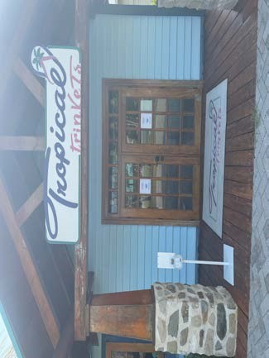  Please Insert Images of your store
Inside the Gift Shop(showing signage and floor marking) | 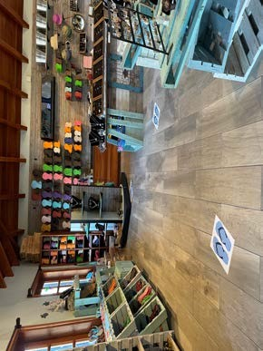  Please Insert Images of your store

4) Implement Enhanced cleaning and Sanitization
- Staff
  - All employees will be provided a hand sanitizer for daily use
  - All staff will wear masks and/or face shields
  - Face shields will be optional depending of employee duties or health risk
  - Gloves will be used depending on employee duties when handling equipment

High Touch Point Areas checklist-
AREA | High Touch Point areas | Solution Used | Frequency | CHECK IF COMPLETED
Office | Desk  Computer  Keyboard  Credit Card machine  Phone
Equipment | All items displayed

- Provide inventory list of cleaning material and PPEs
ITEM | QUANTITY
Surgical Masks
Gloves
Bleach | 5
Bacteria killing agents | 10
Sprayers | 5

- Attached are images of PPE and cleaning equipment
Insert images of all PPE purchased and is in inventory at the store
Example of PPE: 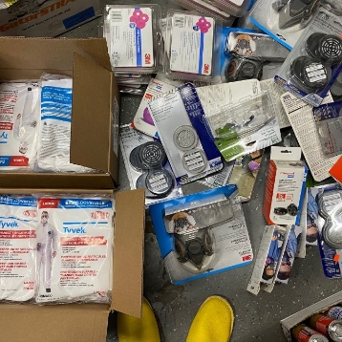

- Disposal of waste
  - All employees will wear protective gloves and face masks when handling trash. Trash bins will be lined with bags and tied off securely when full.
  - All bags with possible contamination will be sealed in red bag and disposed separately.

5) Develop a Response Plan
All staff must follow the following steps to deal with symptomatic person
Kindly insert step by step response plan based on your operations. See samples below

    - Anyone with symptoms will be denied entry into the gift shop/store.
    - Employees who are symptomatic should not report to work and notify Program Manager.
    - Should staff become ill at the gift shop/store; they will be sent home for medical attention.
    - Wait on report from FSTV Gold Standard Manager on how to proceed with employee/guest.
    - Disinfect and sanitize high touch point areas where case may have been in contact

6)Ensure Clear and Consistent Communication
- Signage
Below are images of signage around the entrance area, cashier area, common area and inside store. Reference annex signs of social distancing, proper hand washing and symptoms for constant reminders to guest and staff. You can print and laminate these to stick in strategic locations.

Insert images of signage around the gift shop/store
Area | Picture
For example- Picture of Signs at Entrance | 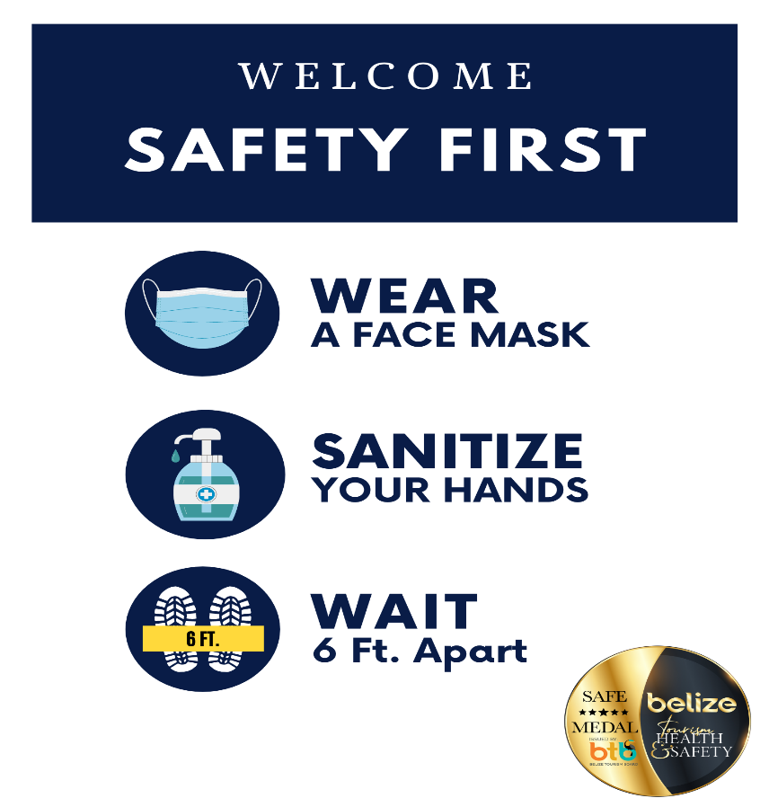
Signs at Cashier Area
Signs Inside the Gift Shop

7)Install Sanitizing Stations
- Attached are images of sanitizing stations installed equipment with soap dispensers, sanitizer gel, single use towels, etc
Insert images below of your sanitizing stations

Area | Picture
Example- Sanitization Station at entrance area
Sanitizing stations at cashier area
Sanitizing stations inside the gift shop or anywhere else

8) Deploy New Technology (If applicable)
- Attached are images of payment process (credit card, pre check-in credit card, website, online transfer, digital ticketing, QR code, etc.

Insert images below of any new technology implemented to make contactless operations

Area | Picture or URL link
Example of contactless payment (online payments, credit card, sanitizing cash station, etc.) | POS Machine for Debit/Credit Cards

9) Implement a Training Plan
- All employees will be trained on Health and Safety protocols implemented at your store/shop. Training offered will be logged using the template below
Images will also be kept for records. (Insert images if available)
Sample Training Log

Training | Date attended staff | Names of staff | Signature

Attach images of training sessions

Annex- Sample Signage
