Standard Operating Procedures for

[Transport Provider Name]

Checklist for Gold Standard Recognition Program

Instructions: The below is a sample template to guide Transport Providers in developing the Standard Operating Procedures (SOP) to obtain Gold Standard Recognition. Transport Providers must complete sections in red and customize template to suit their operations. Once all sections are completed the plan must be submitted to entitygoldstandard@belizetourismboard.org

Name of Transport Provider______________________________
Transport Provider license #______________________________________
Copy of Vehicle/Bus Registration Certificate______________________________________
Declaration:
I hereby certify that all information provided in this application and plan is true, accurate and complete to the best of my knowledge. I have not withheld any information and understand any falsification is illegal and will disqualify this application.
Print Name of Gold Standard Manager_________________________________

Signature of Gold Standard Manager___________________________________

Print Name of General Manager/Owner________________________________

Signature of General Manager/Owner__________________________________

Date: _________________

-------------------------------------------------------------------------------------------------------------------------

1) Appoint a Tourism Gold Standard Manager
- Contact information of the appointed Gold Standard Manager
  - Name________________________________________
  - Phone________________________________________
  - Email_________________________________________
- Name of Alternate Gold Standard Manager
  - Name__________________________________________
  - Phone__________________________________________
  - Email___________________________________________

- Duties and responsibilities of the Gold Standard Manager
- Ensure that all employees know the procedures on how to handle a symptomatic case.
- Ensure that all logs are being followed on each tour.
- Conduct spot checks on tours to ensure all protocols are being followed.
- Ensure all employees have Personal Protective Equipment and cleaning and sanitizing equipment
- Liaise with Ministry of Health on any symptomatic employee or guest and provide any logs necessary for contact tracing
- Ensure that Transport Provider SOPs are reviewed and modified as necessary
- Implement corrective actions when employees and guests are non-compliant with protocols
- List Others: (insert any additional duties/responsibilities assigned but not captured above)
- ____________________________________________________________________________________________________________________________________________________________________________________________________________________________________________________________________________________________________________________________________________________

2) Implement Monitoring and Reporting
Monitoring
  - Employee checks:
    - If employee is sick, he/she should not come to work and report to Program Manager.
    - Every employee will be asked the following questions:
      - Have you been in close contact with a suspected or confirmed case of COVID 19?
      - Are your experiencing a cough, shortness of breath or sore throat
      - Have you had a fever in the last 48 hours?
      - Have you had a loss of smell or taste?
      - Have you had any vomiting or diarrhea in the last 24 hours?
      - Does anyone in your immediate household present these symptoms?
    - If multiple answers are yes, the employee will be isolated and the response plan will be activated.

  - Guests
    - Any symptomatic guest will be isolated and the response plan will be activated.
  - All will be observed for the following symptoms and reported:
    - Less serious symptoms
      - Fever
      - Dry cough
      - Headache
      - Conjunctivitis
      - Tiredness (prior to tour activities)
      - Loss of taste and smell
      - A rash on skin or discoloration of fingers or toes.
      - Aches and pains
      - Sore throat
      - Diarrhea
    - Serious symptoms
      - Difficulty breathing or shortness of breath
      - Chest pain or pressure
      - Loss of taste and smell
    - Any observation of symptoms will be communicated via the Ministry of Health and Wellness (MOHW) hotline 0-800-664- 2273.
    - For contact tracing queries at the district level the following numbers below can be utilized:
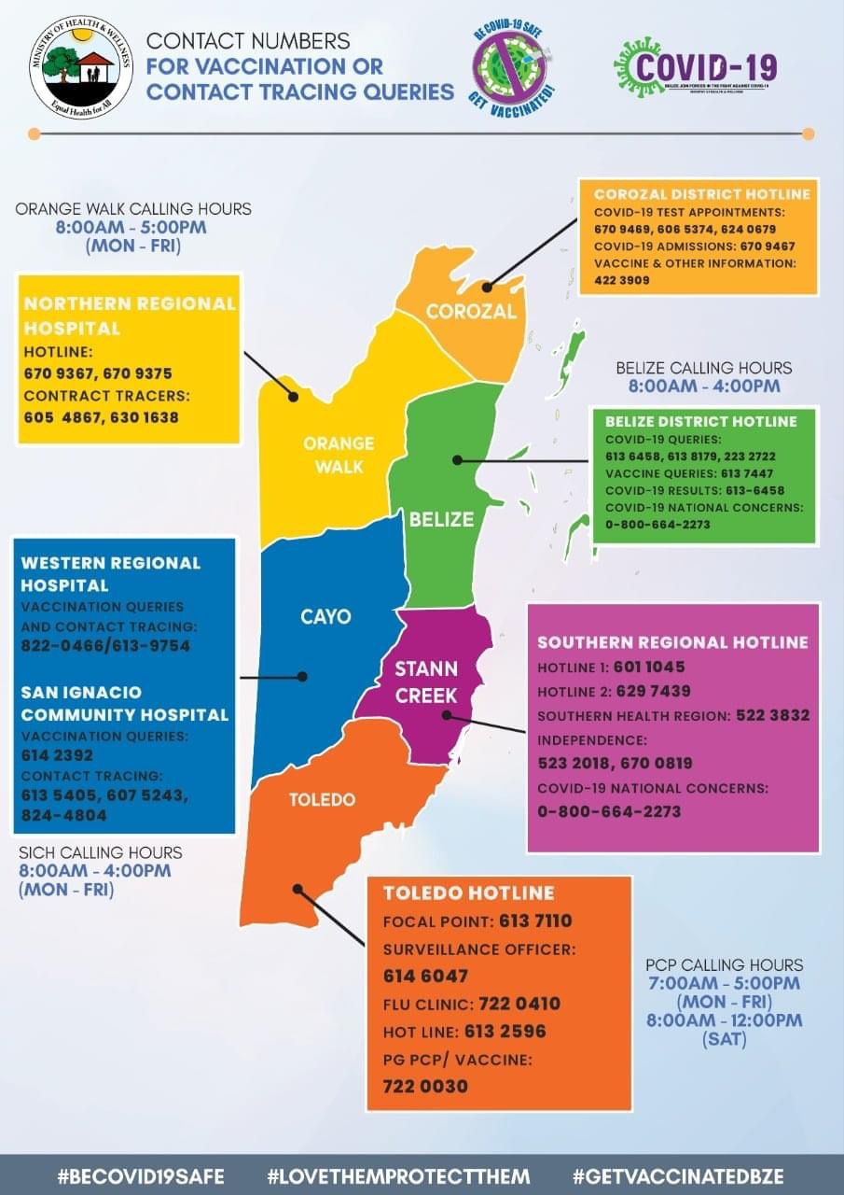

- For reference of reporting, the template below will be used to record any individual displaying symptoms, including elevated temperatures:

  - Templates of Log sheets used:
    - COVID-19 Symptomatic log
COVID-19 Symptomatic Log
Date | Guest or Employee name | Emergency contact information | Gender/Age | Symptoms observed | Place and time observed | Names of those in contact with symptomatic individual | Action taken

3) Implement Enhanced cleaning and Sanitization

- Cleaning and sanitization logs will be kept for all transport vehicle/bus. Below are logs for tracking of enhanced cleaning and sanitization. For reference use below samples or insert image if you already have logs.

Sample Logs
  - Cleaning and sanitization time log fleet

Vehicle/Bus | Employee | Date | Time | Signature
Ex- Vehicle C-1967 | John Doe | Dec 10, 2020 | 5:15pm

- Below is the general guidance for how to conduct enhanced cleaning and sanitization. For reference below are some suggestions or insert images of checklist for each area to be cleaned.
Enhanced Cleaning Checklist for areas being cleaned:
TERMINOLOGIES
Cleaning of visibly dirty surfaces followed by disinfection is a best practice measure for the prevention of COVID-19 in the community setting.
Cleaning
•Cleaning is a pre-disinfection step to remove dirt.
• Removes dust and debris from a surface/s.
• Action by scrubbing, washing and rinsing.
Sanitize
• Reduces the bacteria identified on the product’s label
Disinfection
• Destroys or inactivates both the bacteria and viruses identified on the product’s label
• EPA-approved disinfectant

Vehicle/Bus Cleaning Checklist
Instructions:
- Personal hygiene regarding ‘cough etiquette’ and ‘hand hygiene’ must be observed.
- Keep cleaning products in the vehicle/bus.
- Clean/ Disinfect all high touch points in the vehicle/bus and remove all rubbish from vehicle/bus at the end of the journey/Shift.
Note: Always ensure you wear correct Personal Protective Equipment

vehiclE/Bus HIgh touch areas that require attention:
- Interior/Exterior door handles/knobs
- Window switches/handles/dashboard
- Air vents and controls
- Cup holders
- Radio Controls
- Steering wheel, hand brakes, gear shift
- Seatbelt Clips
- Keys and fuel cap
- Sink faucets & toilet handles
- Door handles/ knobs & handrails
- Toilet door locks
- Trash can flips

- Disposal of waste
  - All employees will wear protective gloves and face masks when handling trash. Trash bins will be lined with bags and tied off securely when full.
  - All bags with possible contamination will be sealed in red bag and disposed separately.

4) Develop a Response Plan
- All staff must follow the following steps to deal with symptomatic guest and staff.
Kindly insert step by step response plan based on your operations. See samples below.

  - Upon Pick Up
    - Temporarily isolate staff/guest at (Insert temporary isolation area here) as soon as symptoms are observed.
    - Immediately contact the Program manager to report observations.
    - Program Manager will contact the MOHW for guidance.
    - Organize for transportation of guest/staff if advised after assessment by MOHW.
    - Program Manager will contact Accommodation, Tour Operator
    - Update logs of COVID-19 case
    - Conduct cleaning and sanitizing of vehicles/buses used for transport
    - log cleaning of all vehicles/buses

  - During transport
    - Temporarily isolate staff/guest at (Insert temporary isolation area here) as soon as symptoms are observed.
    - Immediately contact the Program manager to report observations.
    - Program Manager will contact the MOHW for guidance.
    - Organize for transportation of guest/staff if advised after assessment by MOHW.
    - Program Manager will contact Accommodation or Tour Operator
    - Update logs of COVID-19 case
    - disinfect and sanitize vehicles/buses and equipment used for transport
    - log cleaning of all vehicles/buses

- Closest medical facility identified (Insert name and contact information)
    - _________________________________________
    - _________________________________________

- Additional notifications- Gold Manager(s) will assist guests with contacting their local diplomatic mission. This is often done to register their location and situation in a country if necessary. Should the guest(s) choose to contact the embassy directly they are free to use the local line. Should guest(s) request that the mission be contacted on their behalf then Management will request an electronic copy of their ID for verification purposes.

- Cleaning and disinfecting procedures after symptomatic guest departs:

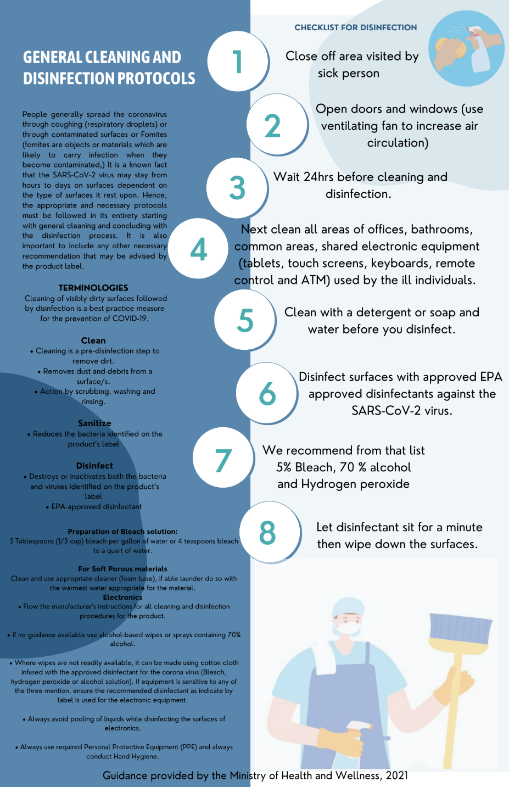

- See below inventory list of cleaning material, equipment and PPEs
ITEM
Insert list of cleaning material, equipment and PPE in stock.

- See below images of PPE and cleaning equipment
Insert images to correspond with your inventory

5) Ensure Clear and Consistent Communication
- Transport policies
- All transport will be executed with the safest measures in all efforts to reduce risk for guests and employees.
- Signage
Below are images of signage around the vehicles, buses (where applicable). (Signs of social distancing, proper hand washing and symptoms for constant reminders to guest and staff. See annex for samples)

Insert images installed in all relevant areas.

7) Install Sanitizing Stations
- See below images of sanitizing stations (installed equipment with soap dispensers, sanitizer gel, single use towels, etc) in all relevant areas (Vehicle, bus etc.)
Insert images and list location of sanitizing station

8) Deploy New Technology
- See below description and images of payment process (credit card, pre check-in credit card, website, online transfer, cash etc.)
Insert description and screenshots or images.

9) Implement a Training Plan
- All employees will be trained on the new protocols implemented. Training offered will be logged using the template below (Insert log if you have your own template). Images will also be kept for records. (Insert images if available)
Sample Training Log
Name of Training | Date attended | Staff Names | Signature

Annex- Sample Signage

